Good afternoon. I am Kathy Tyler, 48170 144th St, Big Stone City, SD 57216. My husband and I live about 3/4 of a mile from a Pipestone swine facility similar to the one being discussed today. I was invited to speak to you today about our experiences of having this facility in our neighborhood. And, yes, I’m an outsider, just like Pipestone and its supporters.
Before you get any idea that I am a city slicker complaining about odor, I grew up on a farm, live on an acreage, and own approximately 400 acres of grassland/farmland—some that we rent to organic farmers—true organic farmers, not the ‘organic’ mentioned in Pipestone’s literature; other land that we rent to a rancher who has a feedlot CAFO permit.

Our neighbors include numerous farmers—both active and retired, retired and working couples, a small organic (70 head maybe) dairy about a mile west, a 700 head dairy one mile south of us, a power plant, and an ethanol production facility.

Pipestone/Teton completed their facility in our neighborhood in 2015 after two lengthy court battles. And our fears were realized. The smell we experience is like no other smell.

A very poignant example: Our bedroom is in the northwest corner of our home. My husband needs to be at work by 6:00 so he goes to bed fairly early. One beautiful fall evening he had gone to bed and left the windows open. When I opened our bedroom door at about 11:00 I was met with a tear-jerking odor. The nauseating smell had flowed from the facility, over a small hill, over our shelterbelt trees, and was sitting in our north yard.

We have two dairies in our neighborhood. One dairy, a small organic dairy of approximately 70 cows, is located about a mile northwest of the pig farm. When they are downwind, they smell the pigs-- while standing in their own dairy yard. The other, a larger dairy, rated at 700 cows, is southeast of the pig barn—about ¾ of a mile. That farmer has had odor in his yard..on the opposite sides of his barns.

Our neighbors and we kept track for close to a year of the smell. What it boils down to is that if you are downwind from the facility, you will smell it. I’ve personally smelled the barns up to 3 miles away. Others have claimed its odor up to five miles away. Some days it’s worse than others; it depends on cloud cover, humidity, wind speed, etc.

We were told the odor would be minimal as you may have been told. Not a true statement. We haven’t had our windows open since the facility opened. (Bad experience.)

From the time of the completion of the buildings, we had to fight for correct installation of the biofilters—a condition that our zoning board put on them. That’s another story in itself…an ugly story. They did install biofilters on the manure pit fans…but it still stinks. And think about it, if there were no pit fans, the pigs would basically die of the gases that come off those pits. So they are sending air into the atmosphere that would kill the pigs. They were supposed to install the ‘most effective’ according to the motion made at their hearing. They did not, according to a former SDSU professor, Dr. Erin Cortus. There are no filters on the main fans. (See Hand County #3 document.)

Oh, we can’t forget the manure pipe situation. Our county gave Pipestone permission to place manure pipes in the right-of-way, OUR ditches; land on which we pay taxes. Complaints again. Pipestone, not once asked for permission. Then they started digging up driveways without permission and township roads, etc. Off to court we went again. Tyler versus Grant County. The opposition bowed out at the last minute; we won; counties cannot give right-of-way access to manure pipe users. And the state legislature agreed by not passing a law making manure pipes public utilities. Current dairy operator….asking permission; doing it right.

History of damaged pipe. Winter of 2017. Still not fixed. One of two damaged pipes. Township road; incorrectly installed….sticking way out. Who’s going to get the blame when a four wheeler or snowmobile or horse hits that? It’s not Pipestone….landowner
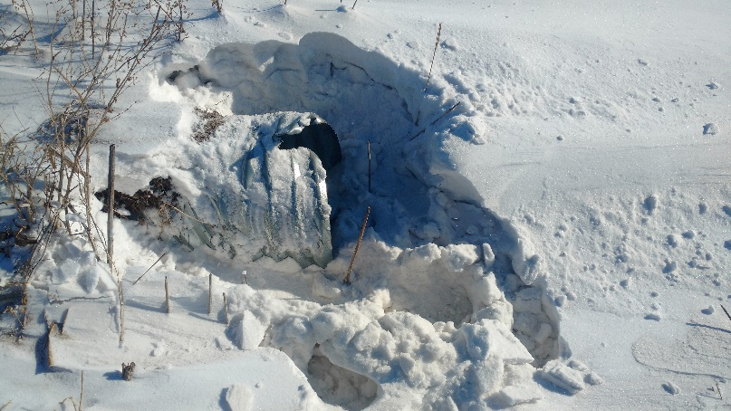

There are rules for installing pipe…Ottertail grades the sides of the road so the pipe is covered. Pipestone doesn’t.

Now, let’s talk shit…oops,…manure. They aren’t supposed to put pipes in the water or on the road. They did, until 2018 legislative testimony brought this to someone’s attention.
Manure pipe through Whetstone Creek:
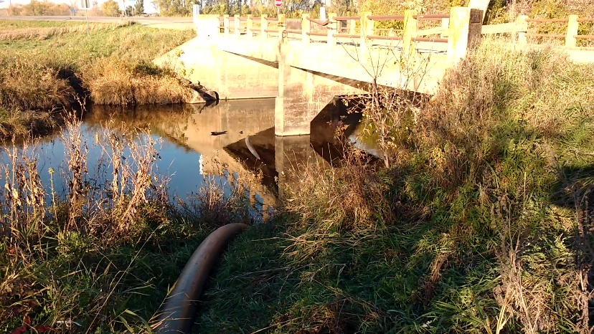

And there not supposed to puddle the manure, but they do.
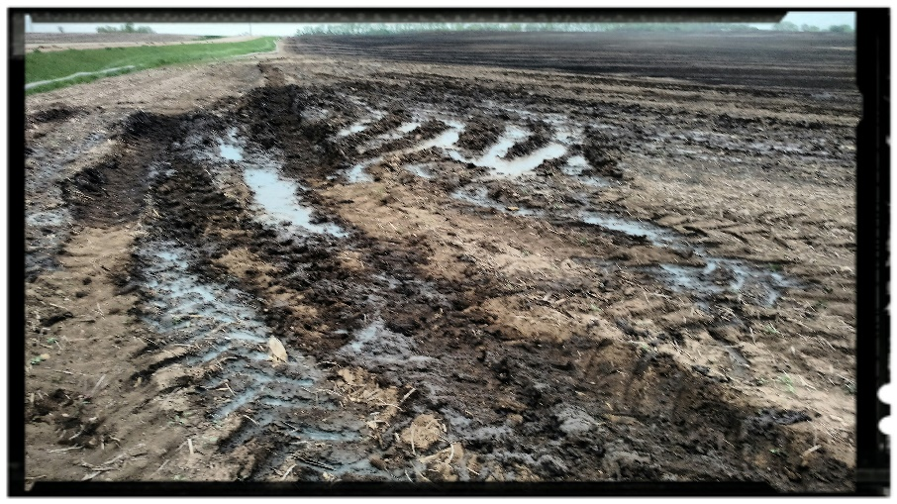
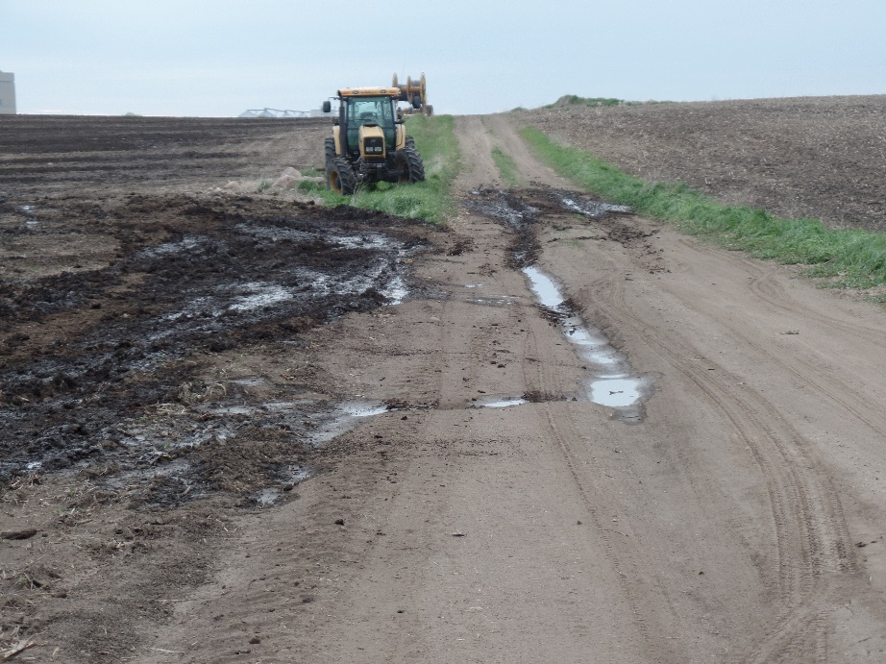
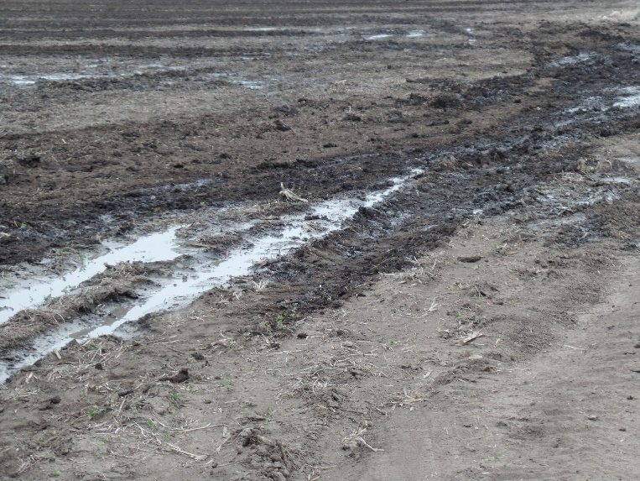

I know of nothing good that the facility in Grant County has done. Oh, they donate a pig or two for a meal, and they donated money to the Big Stone School…bribery, but that’s about it. There’s no more corn sold than before or soybeans. The facility is a group of ugly colored barns on top of what once a beautiful landscape.
The owners are from out-of-state. They get the money; we get the poop. Most of the contractors and building materials were from out-of-state; the feed and propane comes from out-of-state. The community is split. Property values of neighboring residences have declined. $46,000 per year in taxes doesn’t even touch the degradation of health and welfare of neighbors.
Economic development in our community ….. none. Our newspapers are full of help wanted ads; we don’t have enough workers.
And it’s a self-proclaimed bio-hazard site or whatever a ‘high health’ area is:
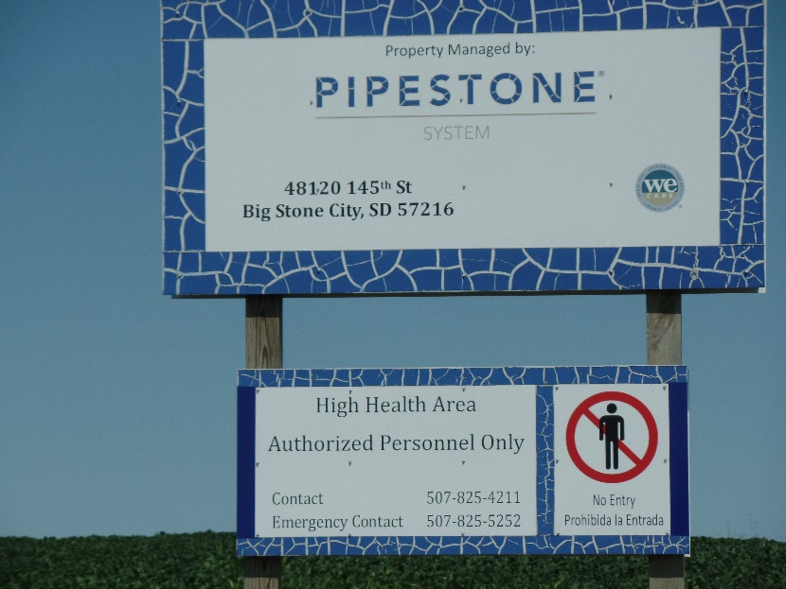

We cannot leave our windows open any longer; walks and horseback rides are a thing of the past—one never knows when the stink will hit. We had planned on putting two building lots for high end homes (on top of a hill overlooking the Whetstone Creek) on the property across the road from where the factory is; that’s no longer even a pipe dream. And it doesn’t quit. Last Sunday I was out pulling weeds; southwest breeze; it hit; I went inside.
I’m sure you will hear scoffs at those remarks, just a ‘not in my neighborhood’ comment or two. What I’ve learned from our experiences….threats of harassment suits, accusations of trespassing, near run off the road experiences, horrendous Facebook posts, and nasty letters to the editor—is that not one of those people lives next to one of these facilities. You don’t want this facility in your county.2
Oh, and I forgot; there are also nitrate issues that need to be addressed; issues that the state does not address:
The Des Moines Iowa nitrate lawsuit opening up a lot of people’s eyes: pig manure, nitrates, improper application. There are many studies and articles in trade magazines discussing nitrates. There are ways to mitigate the issue—to insure your water stays clean. The Big Stone facility follows NONE of the practices despite its fields’ locations.
I’ve attached a listing of resources and research summaries that verify my statements. (Hand County #3 Document.)

You have three options for this application.
The first is to grant the permit. I and a whole lot of other people are asking you not to do that.
The second is, that if you feel you need to grant the permit, put conditions on it: most effective biofilters engineered by experts and inspected; tall trees planted around the facility; best practices required for manure application as dictated by research…above and the beyond the minimums required and not enforced by the DENR. Also require any other methods necessary to eliminate the odor and the poisons being carried in the air indicated by that odor.
And the third option: Do not permit this facility in your county. I’m sure that in your zoning regulations or comprehensive plan there’s a statement about health and welfare of the county’s citizens and development for the good of county. There is nothing good about this facility…property values will decline; some of your citizens will become ill; and you’ll probably see only a negligible effect on the tax income for Hand County. No matter what you’ve been told, you do not have to permit this facility. Berg vs Grant County proved that.
I thank you for your time and I stand by for questions.

