HAZARDOUS MATERIAL PLAN

HAND COUNTY

Hand County Local Emergency Planning Committee (LEPC)
415 West 1st Ave, Suite 108
Miller, SD 57362
605-204-0267
Handcounty.em@live.com

EPCRA Emergency Planning and Community Right-To-Know Act (SARA Title III)

HAND COUNTY LOCAL EMERGENCY

PLANNING COMMITTEE

CERTIFICATE OF ADOPTION

HAND COUNTY LOCAL EMERGENCY PLANNING COMMITTEE IN A REGULAR MEETING ON,Click here to enter text. HEREBY APPROVES THE HAZARDOUS MATERIALS EMERGENCY RESPONSE PLAN AS THE OFFICIAL DOCUMENT FOR ALL HAZARDOUS MATERIALS RESPONSES WITHIN HAND COUNTY.

CHAIR, HAND COUNTY LEPC

Signature:

ATTESTED:Click here to enter text.

Signature:

SECRETARY,HAND COUNTY LEPC

TABLE OF CONTENTS

Table of Contents --- Promulgation Page 3
Emergency Contact Information Page 4
LEPC Membership Roster --- Page 14
Plan of Operation --- Page 17
Fixed Facility Plans/Site Information --- Page 25
Transportation Routes (maps) --- Page 53

Chemical Summary Information --- Page 60
General Guidelines for all Emergency Responders --- Page 63
Farmers & SARA & Title III --- Page 71
Glossary --- Page 74
Mid Dakota Rural Water System Map Page 81
Appendix A Hazardous Material Incident Reporting Information (form) --- Page 82

Hand County

Local Emergency Planning Committee

Miller, South Dakota

Pursuant to Title III of the Superfund Amendments and Reauthorization Act (SARA), the Governor of South Dakota designated a State Emergency Response Commission (SERC) to implement a hazardous materials emergency response program. The SERC has approved the individuals on the following list as the Local Emergency Planning Committee (LEPC) for Hand County.

The SERC may be contacted either by writing:

State Emergency Response Commission
Department of Environment and Natural Resources
523 East Capitol Street - Foss Building
Pierre, SD 57501

or by calling: 605-773-3296 normal office hours

The LEPC may be contacted either in writing:

Hand County LEPC

415 West 1st Ave, Suite 108

Miller, South Dakota 57362

or by calling: (605) 853-2408 normal office hours

(605) 204-0267 after office hours

The Local Emergency Planning Committee holds public meetings in the Assembly Room of the Hand County Courthouse. Meetings are on the second Tuesday of every even month (February, April, June, August, October, December). Notices of the meetings are posted in The Miller Press prior to the meeting. Any request for information or documents can be made in writing to the address listed above.

Emergency Notification Roster

County Dispatch | Phone (605) 853-2408
County Emergency Coordinator | Phone (605) 204-0267
County Emergency Management Director | Phone (605) 204-0267
SD Dept. of Environment and Natural Resources | Phone (605) 773-3296
SD Office of Emergency Management (24 hours) | Phone (605) 773-3231
CHEMTREC | Phone 1-800-424-8802

COMMUNITY | FIRE CHIEF | PHONE NUMBER
Miller Fire Department | Steve Resel | 853-3817
Polo Fire Department | Patrick Schaefers | 530-3014
Ree Hieghts Fire Dept | Dylan Dueter | 943-5542
South Hand Fire Dept | Jeff Tong | 450-0995

HAZARDOUS MATERIALS RELEASE – Notification of your organization/agency will set in motion a series events based upon the information provided. Actions may range from dispatching additional trained personnel to the scene to activating the local emergency response plan. Ensure that local fire and police departments have been notified.

Emergency Notification Roster
Hand County

Public Safety Center(County Dispatch/Sheriff’s Office)  Sheriff | 605-853-2408
Emergency Management Coordinator (Alex Roeber) Cell | 605-204-0267
SD Office of Emergency Management (24 hours) | 605-773-3231
SD Dept. of Environment and Natural Resources | 605-773-3296
National Weather Service  Aberdeen  Rapid City  Pierre | 605-225-5594  605-341-0346  800-852-9470
CHEMTREC | 800-424-9300

Emergency Notification Roster
Hand County

Emergency Operating Personnel
Emergency Contact 24-Hour

Name | Address | City | Home Phone # | Work Phone # | Cell # Notes  (Radio Call Sign)
Commissioners
Jim Iverson | 1000 W 2nd St | Miller | 853-3120
Jim Jones | 218 E 8th St | Miller | 853-2769
Gilbert Rodgers | 20713 371st Ave | Wessington | 458-2378
JD Wangsness | 20211 355th Ave | Miller | 853-3493
Luke Wernsmann | 18790 354th Ave | Miller | 853-3848
Emergency Management
Alex Roeber | 415 W 1st Ave | Miller |  | 204-0267 | 33-DM-1
Patti Pudwill | 416 Production St N | Aberdeen |  | 626-2031 | Regional Coordinator
State Office |  | Pierre |  | 773-3231
Sheriff
Doug DeBoer | 415 W 1st Ave | Miller |  | 853-2408 | 33-1A
Steve Flanagan | 415 W 1st Ave | Miller |  | 853-2408 | 33-1B
Dan Thibault | 415 W 1st Ave | Miller |  | 853-2408 | 33-1C
Jim Keeter | 415 W 1st Ave | Miller | 853-2679 |  | 33-1K
Miller Police Dept
Chief Shannon Speck | 120 W 1st St | Miller |  | 853-2400 | 33-2A
Deputy Chief Wayne Ames | 120 W 1st St | Miller |  | 853-2400 | 33-2B
Officer Chris Henrickson | 120 W 1st St | Miller |  | 853-2400 | 33-2C
Officer Jim Henson | 120 W 1st St | Miller |  | 893-2400 | 33-2H
Highway Super.
Jeff Hargens | 810 E 2nd St | Miller | 853-3292
Fire Chiefs
(Miller)  Stevel Resel |  | Miller | 853-3817
(Polo)  Patrick Schaefers |  | Polo |  |  | 530-3014 (c)
(Ree Heights)  Dylan Dueter |  | Ree Heights | 943-5542
(South Hand)  Jeff Tong |  | Miller |  |  | 450-0995 (c)
Coroner
Dr. Stephan Schroeder | PO Box 287 | Miller |  | 853-2421
Hutterite Colonies
(Millerdale Colony)  Mike Waldner | 35350 206th St | Miller | 853-0652
Neighboring County Emergency Managers
Beadle | 450 3rd St SW, Suite 102 | Huron |  | 353-8421 350-2038 | bcmgmt@midconetowrk.com
Buffalo/Brule  Kathryn Benton | 300 S Courtland St, Suite 106 | Chamberlain |  | 293-3231 | brbufem@midstatesd.net
Jerauld  Roger Dwyer | PO Box 346 | Wessington Springs |  | 539-0234 | oemdwyer@venturecomm.net
Spink  Larry Tebben | 210 E 7th Ave | Redfield |  | 472-4591 | Ltebben.spinkem@nrctv.com
Hyde  Brent Hovland | PO Box 413 | Highmore |  | 852-2595 295-8858 | hydecoem@gmail.com
Faulk  Mark Toennies | PO Box 157 | Faulkton |  | 596-6294  252-8002 | faulkem@venturecomm.net

MEMBERSHIP ROSTER

MEMBERSHIP ROSTER OF THE HAND COUNTY LEPC

CHAIRMAN Tom Lichty

MAILING ADDRESS 300 West 5th St

Miller, SD

LEPC ROSTER

NAME REPRESENTING ADDRESS PHONE NO.

Alex Roeber | EM - Hand County | 415 W 1st Avenue Suite #108, Miller | 853-2408 | Handcounty.em@live.com
Rodney Gortmaker | Fire Service | 327 E 9th Street, Miller | 853-2369 | krgortmaker@hur.midco.net
Tom Lichty | EMT | 300 West 5th Street, Miller | 853-2421 | Thomas.lichty@avera.org
Ron Hoftiezer | Miller Street Dept. / Local Official | 120 W 2nd St, Miller | 853-2705 | Ron.hoftiezer@cityofmiller.com
Doug Deboer | Law Enforcement | 415 W 1st Avenue Suite #102, Miller | 853-2408 | handcosheriff@hotmail.com
Wilbur Ellis | Chemical Facility | 609 W 14th St, Miller | 853-2382 | sksporrer@hur.midco.net
Jeff Hargens | County Highway / Transportation | 810 E 2nd Street, Miller | 853-3292 | handcohwy@yahoo.com
Bill Lewellen | Miller City Electric / Local Official | 120 W 2nd St, Miller | 204-0561
Shannon Speck | Miller PD / Law Enforcement | 120 W 2nd St, Miller | 853-2400 | Shannon.speck@cityofmiller.com
Steve Resel | Miller Fire Chief / Fire Service | 2205 N Broadway Ave, Miller | 853-2220 (unattended) | slchresel@yahoo.com
Erv Kolda | Polo Fire Chief / Fire Service | 17996 Polo Drive, Orient | 293-2800 | tkolda@venturecomm.net
Renae Phinney | Ree Heights Mayor/ Elected Official | PO Box 123, Ree Heights | 943-5628
Rich Waldrop | Chemical Facility / Bobs Gas | 4 3rd Street NW, Miller | 853-3710
The Miller Press | Media | 114 W 3rd Street, Miller | 853-3575 | news@themillerpress.com
Jerry Vanzee | Chemical Facility/ North Central Farmers Elevator | 1103 N Broadway, Miller | 853-2351
Elaine Cary | Hand County | 415 W 1st Avenue, Miller | 853-3789 | Janitor.handcoem@midconetwork.com
Cory Flor | South Dakota Game, Fish & Parks | Miller | 680-0003 | Cory.flor@state.sd.us
Mike Moncur | Dakota Energy / Utilities | 1003 N Broadway, Miller | 853-2453
Sandi Selting | Elected Official / County Auditor | 415 West 1st Avenue, Miller | 853-2182 | Auditor.handcoem@midconetwork.com
Dan Trefz | Superintendant / Miller School District | 623 E 4th Street, Miller | 853-2614 | Dan.trefz@k12.sd.us
Mike Pettit | State Department of Transportation | 1208 E 3rd Avenue, Miller | 853-2212 | Michael.pettit@state.sd.us
Terry Manning | City of Miller Water & Sewer | 120 W 2nd St, Miller | 204-0565 | Terry.manning@cityofmiller.com
Todd Waring | Red Cross/Ree Heights Fire | 35031 213th Street, Ree Heights | 943-5597 | ttwaring@venturecomm.net
Jeffrey Tong | South Hand Fire Chief/Rancher | 21330 354th Ave, Miller | 853-2861 | jtangus@mncomm.com
Charlie Fawcett | Ree Height Fire Department | Ree Heights | 943-5693 | Atvfixer07@gmail.com
Tim Zacher | Greenline Implement | 1810 N Broadway, Miller | 853-2482
John Dunlap | South Dakota Game Fish & Parks | 415 W 1st Ave, Miller | 730-1570 | Jonathon.dunlap@state.sd.us

PLAN OF OPERATIONS

I. INTRODUCTION

A variety of hazardous materials are transported, stored, and used within the Hand County area on a daily basis. These hazardous materials include toxic chemicals, flammable liquids and gases, and radioactive materials. These hazardous materials are used in agriculture, industry, business, and other commercial and domestic applications.

When properly used, applied, controlled, and contained, hazardous materials can be beneficial to our society. When improperly handled or accidentally released they pose a threat to life, property, and the environment. A fast and efficient response is imperative to effective management and mitigation of an incident. Inadequate response and recovery operations can be very costly in terms of lives, dollars, and environmental damage. Most hazardous materials incidents require a multi-disciplinary approach with all responders participating in a coordinated effort. This procedure is not a stand-alone plan. It must be supported by other state, local, and facility emergency operations plans.

A. PURPOSE

Your local emergency plan is designed to provide hazard specific procedures and guidelines for response to an actual incident involving a hazardous material. This plan will also assist LEPCs in complying with existing State and Federal legislation. This document will covers the nine required elements of a local emergency plan as outlined in Title III legislation.

Every community in South Dakota must be included as part of a comprehensive emergency operations plan. This plan will enable the LEPC, local fire departments, public institutions, health, professionals, industries, small businesses, farmers, and others to identify types and locations of chemical hazards, vulnerable areas and populations, and the risk of accidents and their effects on the community.

B. OBJECTIVES

1. To identify the facilities and transportation routes where hazardous materials are present.

2. To establish emergency response procedures, including evacuation plans, for dealing with accidental chemical releases.

3. To set up notification procedures for those who will respond to a hazardous materials incident.

4. To establish methods for determining the occurrence and severity of a release and the areas and populations likely to be affected.

5. To establish ways to notify the public of a release.

6. To identify the emergency equipment available in the community, including equipment at each facility.

7. To train local emergency response and medical workers to respond to chemical emergencies.

8. To establish methods and schedules for conducting exercises to test elements of the plan.

9. To designate a community coordinator and facility coordinators to carry out the plan.

The plan is designed to cover/respond to the release(s) and potential release(s) of hazardous materials to the air, land, surface waters, and aquifers. This may pose an immediate or long-term threat which resulted from an accident or emergency release involving storage, transportation, or use of hazardous materials.

NOTE: The term “release(s)” means any spilling, leaking, pumping, pouring, emitting, emptying, discharging, escaping, leaching, dumping, or disposing into the environment (including the abandonment or discarding of barrels, containers, and other closed receptacles) of any hazardous chemical, extremely hazardous substance, radioactive material, or toxic chemicals.

C. AUTHORITIES

• The Superfund Amendment and Reauthorization Act, 1986, SARA Title III Legislation - 40
CFR Parts 300 and 355
• The Comprehensive Environmental Response, Compensation, and Liability Act, 1980 (CERCLA)
• The Federal Water Pollution Act and Clean Water Act
• SDCL 34.48A; otherwise known as the South Dakota Office of Emergency Management
• South Dakota Codified Laws:

SDCL 34-38; Flammable Liquids
SDCL 34-39; Liquefied Petroleum Gases
SDCL 34A-1.45; Air Pollution SDCL 34A-2; Water Pollution
SDCL 34A-6; Hazardous Waste, Solid Waste Disposal
SDCL 38-19; Commercial Fertilizer
SDCL 38-20A; Pesticides
SDCL 38-21; Agricultural Pesticide Application

D. REFERENCES

• Title III of the Superfund Amendments and Reauthorization Act, 1986, also known as the
Emergency Planning and Community Right-to-Know Act, 1986
• Local Emergency Operations Plans (LEOP)
• South Dakota Emergency Operations Plan
• Hazardous Materials Emergency Planning Guide, NRT-1
• South Dakota Codified Law (SDCL)
• 1996 Emergency Response Guidebook - DOT

II. OPERATIONS

A. County emergency operations plans establish roles and responsibilities of the various local government organizations by function. Nine functions common to emergency operations for any hazardous materials incident are: direction and control, administration, health and medical, warning, communication, public works, damage assessment, public safety, and individual and family assistance. Response personnel roles and responsibilities are based on their day to day assignments. Therefore, county, city, and facility emergency operations plans must be utilized to support this plan.

Hazardous materials operations will be executed in the phases of preparedness, response, recovery, and mitigation.

1. The preparedness phase will consist of locating and identifying hazardous materials.
This will include documentation and dissemination of information as required by Title III legislation. Information must be gathered from each reporting facility and include location, quantity, and type of material being stored. Any facility which has a quantity of extremely hazardous material above the threshold planning quantity (TPQ) must notify both the SERC and LEPC. This information will be reported to local fire departments for their use.

2. Response provides procedures for city, county, and other personnel to follow during a hazardous materials incident. Under SARA Title III a facility must immediately notify the LEPC and SERC of the release of more than a predetermined amount of reportable chemicals. Chemicals covered in this section include not only the extremely hazardous substances but also several hundred hazardous substances subject to notification requirements.

3. Recovery guidelines provide for removal and disposal of hazardous materials.

4. Mitigation provides guidelines for scheduling emergency responder training and exercises which test this plan. This will result in recommendations for improvements in response capabilities.

B. EMERGENCY RESPONSE PREPAREDNESS

The LEPC of Hand County will review and update facility information which includes facility plans, chemical lists and locations within the facilities, facility emergency coordinators, and available facility equipment.

The LEPC is also responsible for:

1. Identifying and mapping transportation routes of hazardous materials.

2. Establishing emergency response procedures and evacuation plans for communities.

3. Setting up notification procedures for those who will respond to hazardous materials incidents.

4. Establishing methods for estimating the occurrence and severity of releases and the areas and populations likely affected.

5. Establishing ways to notify the public of releases.

6. Maintaining a training and exercising program for local emergency response personnel.

7. Designating a community coordinator and facility coordinators to carry out the plan.

C. HAZARDOUS MATERIALS RESPONSE

1. NOTIFICATION - All facilities must make an emergency notification of a release of a hazardous material that exceeds the reportable quantity for that substance in accordance with Superfund Amendments and Reauthorization Act of 1986, Title III, Section 304.

a. Initial Notification - The county dispatcher will serve as the 24 hour contact for notification of all hazardous material incidents.

b. The dispatcher will alert all agencies listed on the emergency notification roster in this plan.

c. All incoming reports will contain the information as shown on the Hazardous Materials Incident Reporting Information Form which is included in this plan as an attachment.

d. The Office of Emergency Management will be notified using the 24 hour number 773-3231. The office will then notify the appropriate agency or agencies as necessary.

2. COMMAND AND CONTROL

a. Upon the occurrence of a hazardous material release or threatened release, control of the situation will be assumed by the initial public safety officer who will become the incident commander and will be authorized to order an evacuation. The acting incident commander will immediately establish an on- scene command post with communication capabilities outside the immediate danger area.

b. The incident commander or his designee shall determine the type, location, and quantity of hazardous material using the facility plan. After determining the extent of the incident a restricted area will be established to control entry and exit into and out of the area.

c. The incident commander is in charge of the command post and all emergency and support agency supervisors or designees will report to this area and operate under his or her directions prior to entering the restricted area.

d. The incident commander shall determine the extent of the threat and the need for additional emergency personnel and evacuation.

e. Each responding agency will conduct its operation in accordance with standard operating procedures as outlined in -each- County Local Emergency operations Plan (LEOP). However, all operational activities must be coordinated with the central command post and the incident commander.

f. The incident commander in conjunction with other responding personnel must take the following actions as outlined in the Hazardous Materials Incident Analysis Student Manual, DECIDE.

• Detect hazardous materials presence
• Estimate likely harm potential
• Choose response tasks/objectives
• Identify action options
• Do best option
• Evaluate progress

1) Keep all persons a safe distance from the incident area until the extent of the hazard is determined.
2) Requirements for performing accident assessment, control and containment, decontamination, and cleanup will be provided by personnel from the appropriate designated agency.
3) Avoid exposure to smoke, dust, mists, liquids, radioactive materials, or any unknown materials.
4) Emergency personnel will enter and leave the restricted area through designated checkpoints for monitoring and decontamination.

5) A record will be maintained to log entries and exits of personnel on the scene. In addition, a record of decontamination procedures on each individual will be kept.
6) If radioactive materials are involved, appropriate action should be taken.
7) Appropriate protective clothing and equipment will be worn as determined by the incident commander.
8) A log of events will be kept at the central command post by a person designated by the incident commander. If possible a videotape log should be made of the incident response.

3. EVACUATION

a. Refer to the facility operations plan for an evacuation procedure both on and off site. In the early stages of incident response, the facility emergency coordinator is responsible to recommend to local officials when to initiate an evacuation. When the local public safety officials are able to assess the situation, all decisions concerning the extent and duration of the evacuation will become a local incident command decision.

b. If evacuation is implemented, the Local Emergency Operations Plan (LEOP) is to be utilized to ensure that:

1) Public safety officials will conduct off-site evacuation operations (warning, restricted roads or other areas, barricades, transportation, etc.) depending on the incident assessment and analysis.
2) Activation of the individual and family assistance function to coordinate care of evacuees.
3) Warning and communication functions are used to provide appropriate information to affected citizens and emergency workers.

4. WARNING / PUBLIC NOTIFICATION

a. Refer to the appropriate county or city emergency operations plan for implementation.

b. Refer to the county emergency broadcast station plan for implementing the local area EAS. Request state support for statewide EAS coordination by contacting the Office of Emergency Management at 773-3231.

5. CONTAINMENT AND CONTROL OF LIFE THREATENING HAZARDS

a. All reasonable efforts should be made by on-scene personnel to treat injured persons, suppress fires, and contain and stabilize the hazardous material(s). These activities might occur concurrently but should precedence be given it is recommended to proceed as follows:
1) Evacuate and treat all casualties - lifesaving activity takes precedence in all situations.

2) Suppress any fires as quickly as possible.
3) Control the release by stopping flow, spillage, or leakage if possible.
4) Contain the released hazardous material in the smallest area possible.

D. RECOVERY

The coordination of recovery will be the responsibility of the county emergency manager. He or she will coordinate with the SD Office of Emergency Management (SDOEM). The incident commander and county emergency manager will coordinate on-site recovery operations in cooperation with all responding state and federal agencies.

1. CLEAN-UP AND DISPOSAL OF HAZARDOUS MATERIALS

Reference 42 US Code Section 5-6921 through 6939 e, inclusive (Federal Resource Conservation Recovery Act) Hazardous Waste Management provides for the hazardous material owners, shippers, and carriers, to be responsible for clean-up and disposal of hazardous materials.

a. A representative of the LEPC will coordinate with state and private agencies on the monitoring of hazardous material spills for compliance with state and federal clean-up standards.

b. A representative of the LEPC will make recommendations to elected officials for hiring a private contractor to perform clean-up operations if the responsible party fails comply with state and federal regulations.

c. The South Dakota Department of Environment and Natural Resources has responsibility to monitor clean-up and removal of hazardous material and assure that clean-up complies with all applicable state and federal regulations.

2. REPORTING

In the event of a hazardous materials incident several reporting requirements must be accomplished. In addition to initial notification and follow-up incident assessments as described, the entities listed below have a responsibility to submit reports as follow:

a. The facility owner, user, operator, or transporter of the hazardous material will submit written reports to:

1) The State Emergency Response Commission
2) The Local Emergency Planning Committee

b. Local Governments:

1) Cities will provide written reports to the LEPC and the state via the county emergency management director.
2) Counties will provide written reports to the SERC via the Office of
Emergency Management.

These reports will be compiled to include photographs, statements from witnesses, and any other documentation which establishes a record of events.

3. EXPENSES

a. Each agency supervisor is responsible to maintain a record of all expenses incurred. These are to include not only normal personnel and equipment usage but also costs for special equipment, technical expertise, and materials.

b. The shipper or owner is responsible to reimburse the local government for actions required to control, contain, dispose of, and repair the damage from a hazardous materials incident.

c. Records of expenses incurred will be prepared by the city or county finance officer or auditor into a bill of eligible costs which will be presented to the person or company responsible for the incident for payment.

4. TRAINING, EXERCISING, AND UPDATING THE PLAN

a. Updating the Hazardous Materials Plan is a continuous and cooperative effort involving the LEPC, SERC, and local, state, and federal agencies. The plan review and update will be accomplished on a yearly basis.

b. Exercising this plan is necessary to test response capability within communities.
Evaluation can be conducted in a variety of ways. Functional, or full-scale exercises and actual hazardous materials incidents all provide a means of identifying necessary improvements and updates.

Local hazardous materials procedures, local exercise schedules, plan reviews and updates, and exercise critiques will be kept on file with the county emergency management director.

c. Along with exercising this plan all first responders need formal instructions in the preparedness, response, recovery, and mitigation phases of a hazardous materials incident. This information will then be distributed to all first responders, facility emergency coordinators, fire departments, law enforcement, and others who may become involved in an incident.

FIXED FACILITY/SITE INFORMATION AND
FACILITY/SITE SPECIFIC INFORMATION

Reference Same Section In Your LEPC Handbook

Hand County

Local Emergency Planning Committee

Chairperson Tom Lichty

Miller, South Dakota 57362

(605) 853-2408

Dear Facility Representative:

The local Emergency Planning Committee (LEPC) since October, 1988 has been required to develop or update their Hazardous Materials Plan/procedure. The plan/procedure is a federal requirement under the Superfund Amendment Reauthorization Act (SARA) Title III (Hazardous Materials Planning and Community Right-to-Know) legislation.

Prior to this date and at present your LEPCs must have site specific information/update from you as the facility representative. Please review Site Specific Information sheet requirements and a brief explanation of the items.

This information will benefit your operation as well as the county/city emergency operations people, should you experience an actual or potential emergency.

Some of the information that is being requested for the local Hazardous Material Planning procedure requires you, as a facility representative, to obtain from the county emergency manager, i.e. alerting/warning telephone numbers, county, city map standards, etc., if not in your current plan.

The remainder of the information must be gathered as well as researched by the facility representative, if not in your current plan. Please start immediately to fulfill this requirement as the sooner-this information is received, the sooner the total county/city Hazardous Material procedure can be finished. Send the information to:

Hand County, LEPC

415 W 1st Ave, Suite 108

Miller, SD 57362

If, in your opinion, there is other specific information that will help government to more effectively respond to a release or accident at your facility, please submit it with the attached information.

FACILITY PLANS

Reference Same Section In Your LEPC Handbook

EMERGENCY NOTIFICATION ROSTERS
HAND COUNTY
Emergency Service | Contact | Emergency Phone | Office Phone
Ambulance |  | 911
Sheriff | Doug DeBoer | 911 | 853-2408
Coroner | Dr. Stephan Schroeder | 911 | 853-2421
Phone | Midco |  | 800-456-0564  800-888-1300
Fire Chief |  | 911
Electricity | Dakota Energy Cooperative | 800-353-8591 | 352-8591
Water | Mid Dakota Rural Water | 853-3159 | 853-3159

CITY OF MILLER
Emergency Service | Contact | Emergency Phone | Office Phone
Fire Chief | Steve Resel | 911
Electricity | City of Miller |  | 204-0561
Water | City of Miller |  | 204-0565

CITY OF ST LAWRENCE
Emergency Service | Contact | Emergency Phone | Office Phone
Fire Chief |  | 911
Electricity | NorthWestern Energy | 800-245-6977 | 800-245-6977
Water | Mid Dakota Rural Water | 853-3159 | 853-3159

HAND COUNTY FACILITIES

FACILITIES | CONTACT | PHONE NUMBER
Avera Hand County Memorial Hospital | Tom Lichty | 853-0361
Bob’s Gas | Rich Waldrop | 853-3710
Century Link QC (Qwest) | UniCall – Qwest Emergency  Center | 866-864-2255
City of Miller | Ronald Hoftiezer Sr | 853-2705
City of Miller - Airport | Terry Manning | 204-0565
Cowboy Country Stores | Spies Corporation (Watertown) | 853-2404  882-0464
Farmers Oil Co – Orient | Sandra Schulz | 392-2424
Hand County Highway Dept | Jeff Hargens | 853-3292
Highway Store | Mike Ames
Mid Dakota Vegetation | Andrew Canham | 530-8089
Miller Terminal | Jarvis Wipf | 853-9207
NCFE – Miller | Jerry VanZee | 853-2351
NCFE – Miller Bulk Plant | Jerry VanZee | 853-2351
NCFE – Rockham Bulk Plant | Keith Komraus | 450-8562
Pump N Pak | Lorili Simons | 853-3758
South Dakota Soybean Processors – Miller Facility | John Prohaska, Op Group Mgr  Jay Wells, Operations Mgr | 627-6121  853-0024
SD Wheat Growers – Miller Agronomy | Don Herman | 853-3006
South Dakota Wheat Growers | Randy Bertsch | 853-2728
Titan Wind Farm | Tim Lyons | 204-0340
Wilbur-Ellis Company LLC – Miller Air | Darryl Chapin | 853-2382

- Spill Notification Procedures
  - Call Fire Department
  - Call Ambulance (If needed)
  - Call Public Safety Center (Sheriff’s Office)
    - If no answer at Fire Department or the Public Safety Center call the State of South Dakota Emergency Release Hotline and report the spill.
  - Evacuate building!
- Optional
  - If possible, turn off power to property to prevent possible fires / explosions prior to evacuating property.
  - If possible, prevent chemicals from entering sewers and floor drains.
  - If possible, prevent on-lookers / bystanders from entering the property / affected area.
  - Stay up-wind from the affected area.

- On-site Evacuation Plans (Employee Instructions)

- Emergency Resources
  - List all dedicated special use equipment / supplies to be used in the event of a chemical release / spill. If none state so.
  - Chemical Collection Sump
  - Chemical Containment Curbing System
  - Emergency Electrical Disconnect
  - Fire Extinguisher
  - First Aid Kit

- Facility Location Map

Avera Hand County Memorial Hospital
300 W 5th St
Miller, SD 57362
853-2421

Tom Lichty, 853-0361
461-3374 (24 hour emergency #)
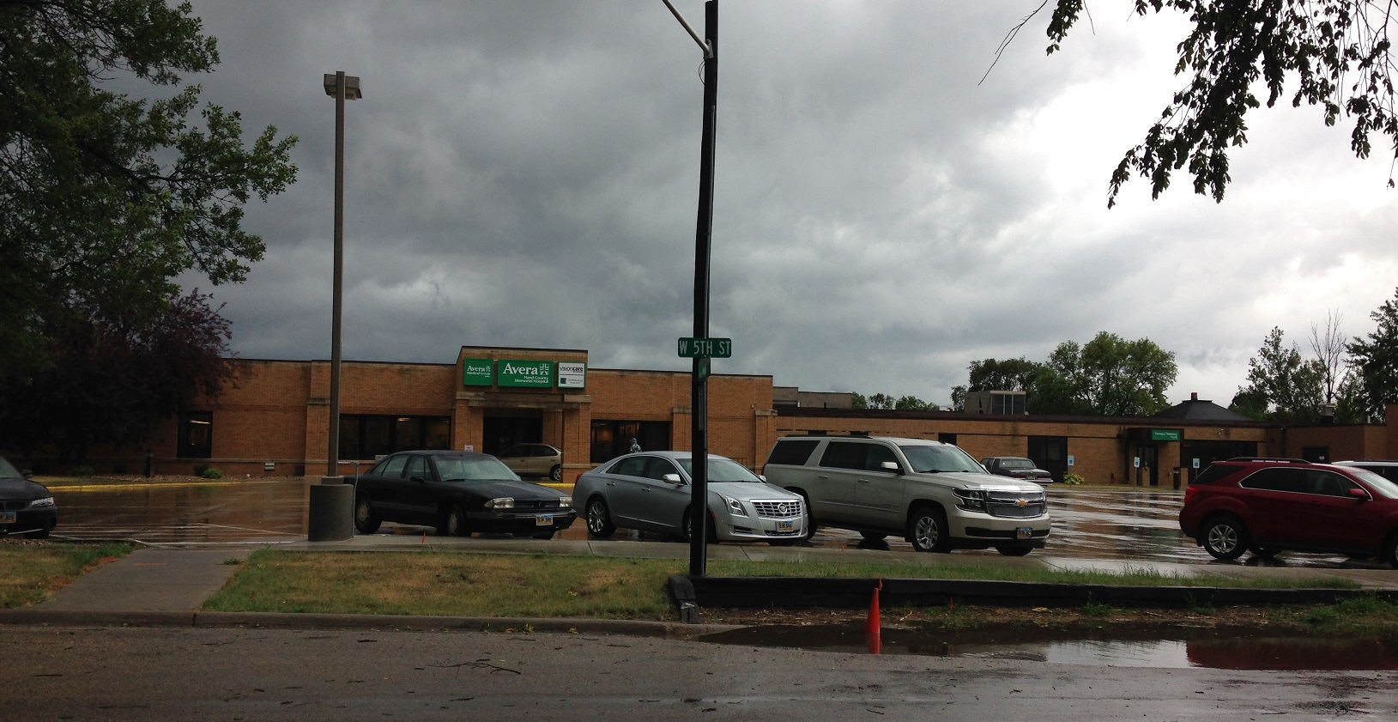

List of Reportable Quantity Chemicals
Chemical | Fire Hazard | Acute Health Hazard | Chronic Health Hazard
Heating Fuel | X | X
Oxygen | X

Bob’s Gas
4 3rd St NE
Miller, SD 57373
853-3710

Rich Waldrop, Owner 853-3710
871-3609 (24 hour emergency #)
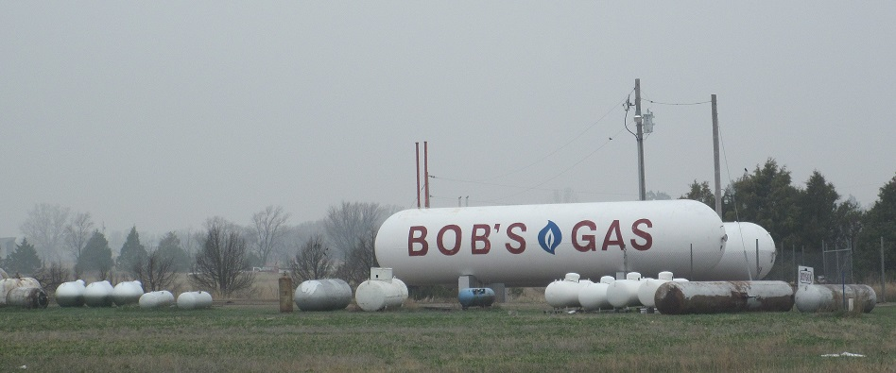

List of Reportable Quantity Chemicals
Chemical | Fire Hazard | Acute Health Hazard | Chronic Health Hazard
Propane | X | X

Century Link QC (Qwest)
126 N Broadway Ave
Miller, SD 57362
866-864-2255

UniCall-Qwest Emergency Center
866-864-2255 (24 hour emergency #)

List of Reportable Quantity Chemicals
Chemical | Fire Hazard | Acute Health Hazard | Chronic Health Hazard
Sulfuric Acid |  | X

City of Miller
120 W 2nd St
Miller, SD 57362
853-2705

Ronald Hoftiezer, Sr., Street Superintendent 853-2705
204-0563 (24 hour emergency #)

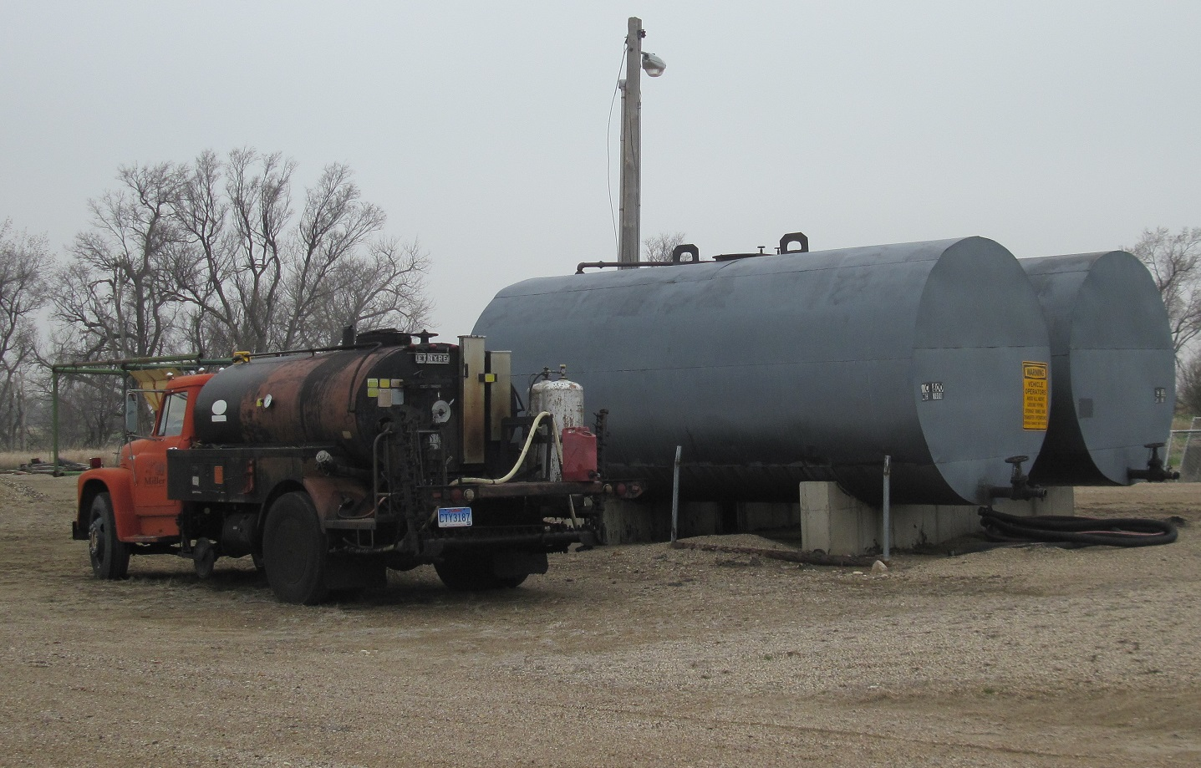

List of Reportable Quantity Chemicals
Chemical | Fire Hazard | Acute Health Hazard | Chronic Health Hazard
Diesel Fuel | X | X | X
MC Road Oil | X |  | X

City of Miller - Airport
120 W 2nd St
Miller, SD 57362
204-0565

Terry Manning, Airport Superintendent 204-0565
204-0565 (24 hour emergency #)
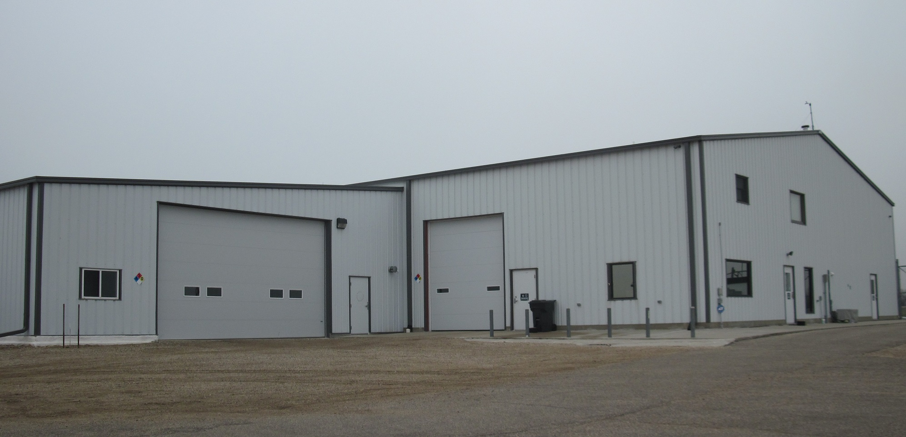
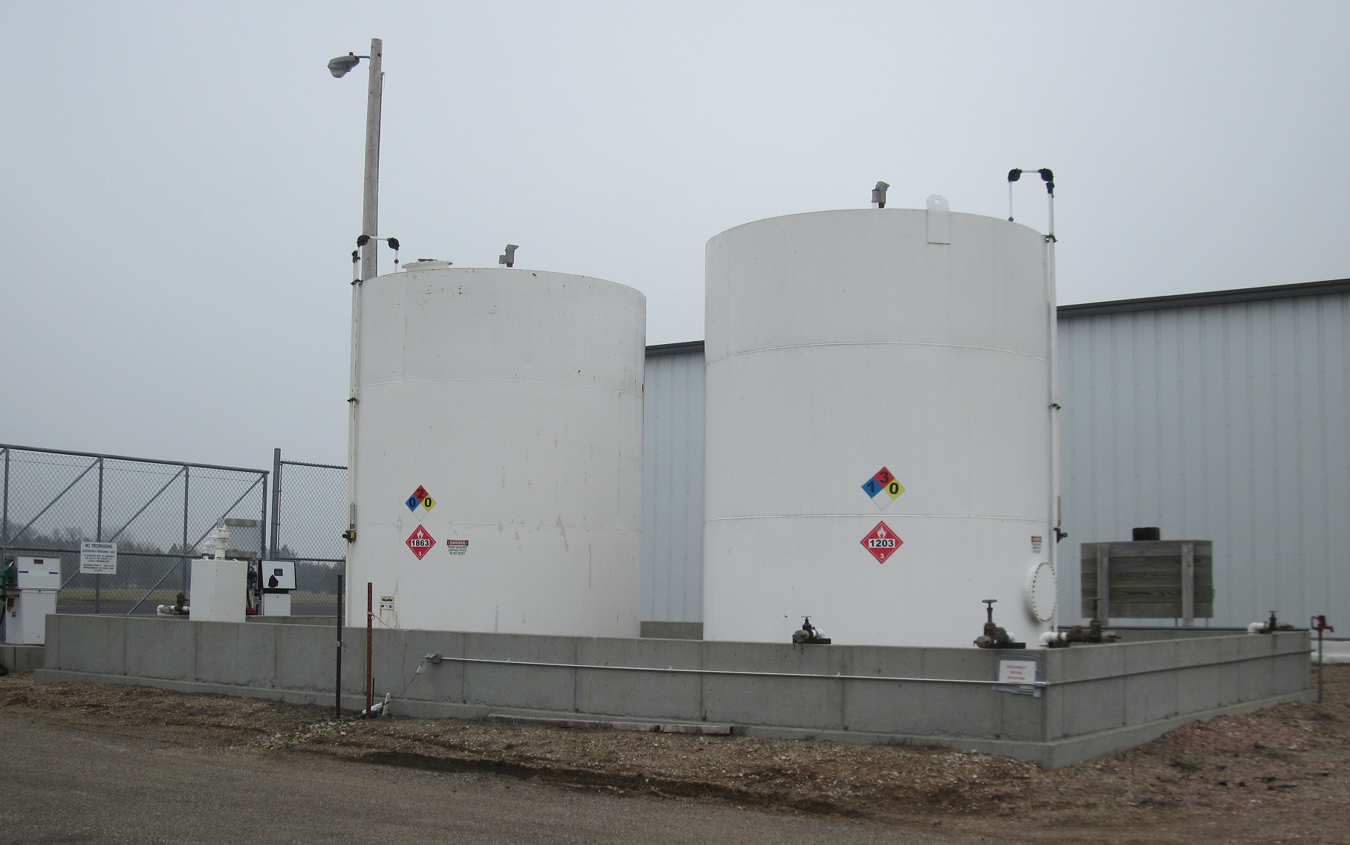
List of Reportable Quantity Chemicals
Chemical | Fire Hazard | Acute Health Hazard | Chronic Health Hazard
List of Reportable Quantity Chemicals Not Available

Cowboy Country Stores
704 N Broadway
Miller, SD 57362
853-2404

Spies Corporation (Watertown) 882-0464
853-2404 (24 hour emergency #)

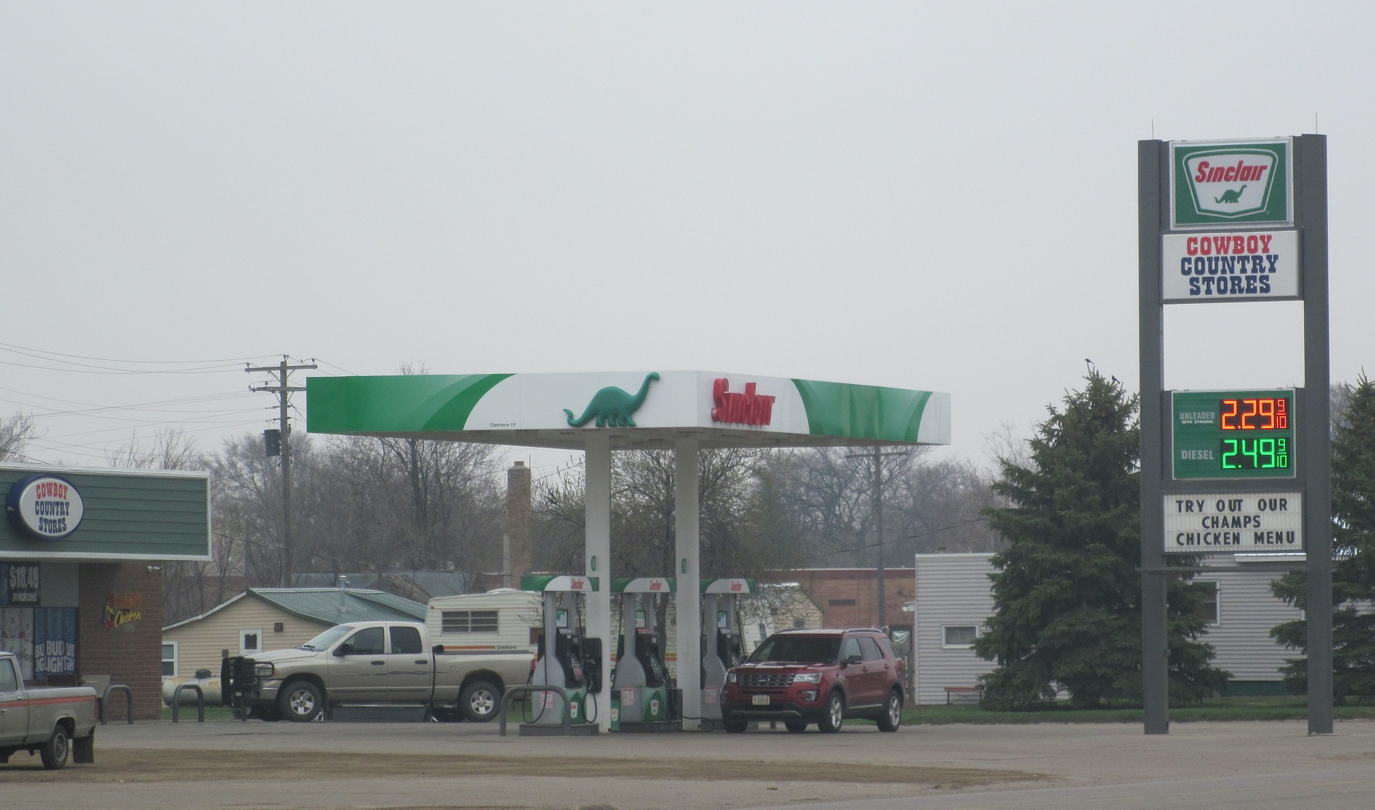
List of Reportable Quantity Chemicals
Chemical | Fire Hazard | Acute Health Hazard | Chronic Health Hazard
List of Reportable Quantity Chemicals Not Available

Farmers Oil Co - Orient
108 Highway 16
Orient, SD 57467
605-392-2424

Sandra Schulz, Manager 392-2424
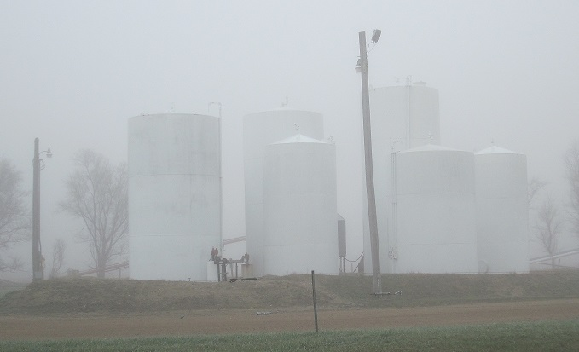
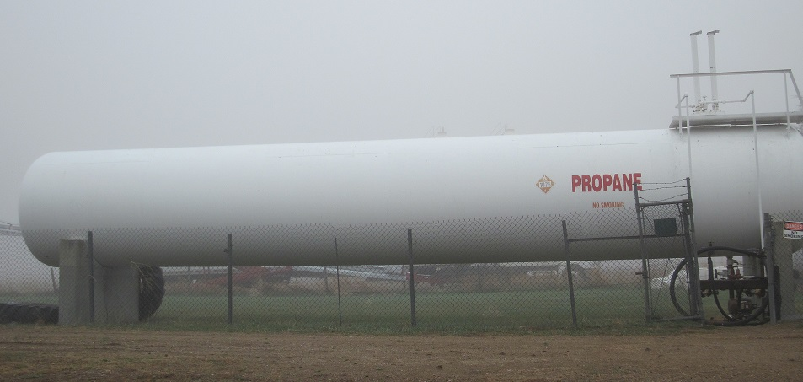
852-2542 (24 hour emergency #)
List of Reportable Quantity Chemicals
Chemical | Fire Hazard | Acute Health Hazard | Chronic Health Hazard
Diesel Fuel | X | X | X
E-85 | X | X | X
Propane | X | X
SNL Gasoline W/Ethanol | X | X | X

Hand County Highway Department
810 E 2nd St
Miller, SD 57362
853-3292

Jeff Hargens, Highway Superintendent 853-3292 (office)
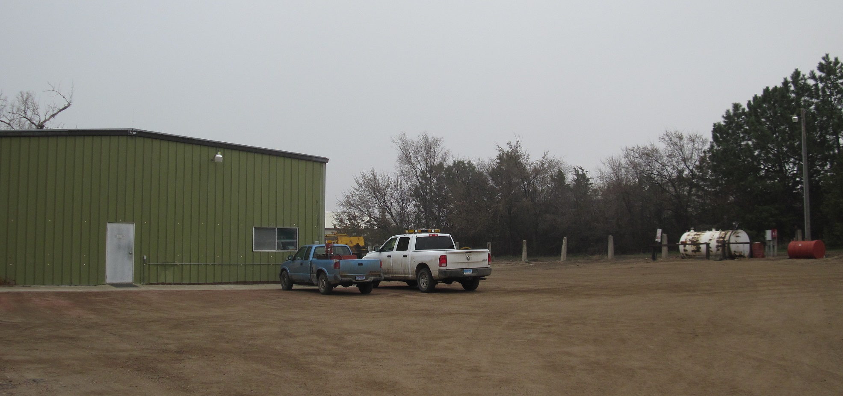
870-0824 (24 hour emergency #)

List of Reportable Quantity Chemicals
Chemical | Fire Hazard | Acute Health Hazard | Chronic Health Hazard
Diesel Fuel | X | X | X
MC Road Oil | X |  | X
RC Road Oil | X |  | X

Highway Store
21999 Highway 45
Miller, SD 57362

Mike Ames
(24 hour emergency #)
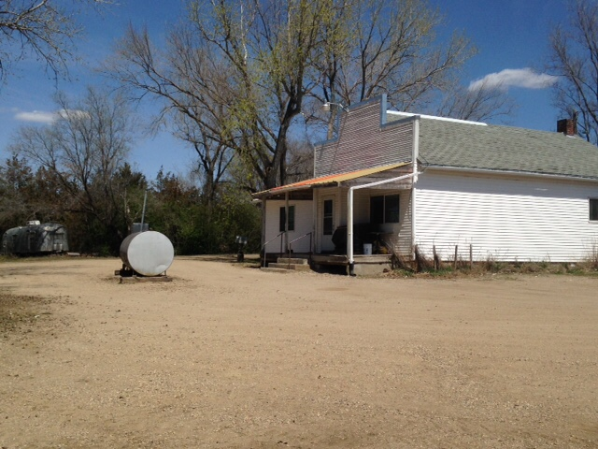

List of Reportable Quantity Chemicals
Chemical | Fire Hazard | Acute Health Hazard | Chronic Health Hazard
List of Reportable Quantity Chemicals Not Available
Miller Terminal
19780 358th Ave
Miller, SD 57362
853-9200

Kevin Kjorsvik, General Manager 875-3278
280-8609 (24 hour emergency #)

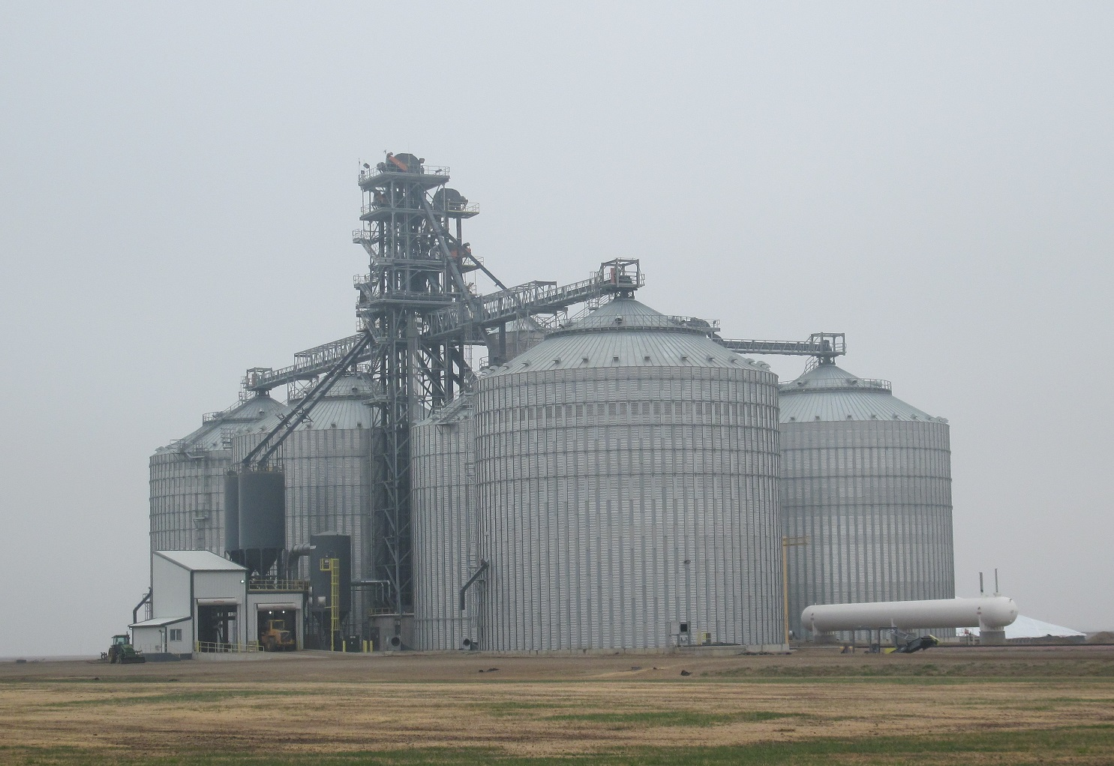
List of Reportable Quantity Chemicals
Chemical | Fire Hazard | Acute Health Hazard | Chronic Health Hazard
Propane | X | X

Mid Dakota Vegetation
25920 Canham Place
Miller, SD 57362
530-8089

Andrew Canham, Co-Owner 530-8089
530-8089 (24 hour emergency #)

List of Reportable Quantity Chemicals
Chemical | Fire Hazard | Acute Health Hazard | Chronic Health Hazard
Below threshold for reportable quantity chemicals

North Central Farmers Elevator - Miller
1103 N Broadway Ave
Miller, SD 57362
853-2351

Jerry VanZee, Manager 853-2351
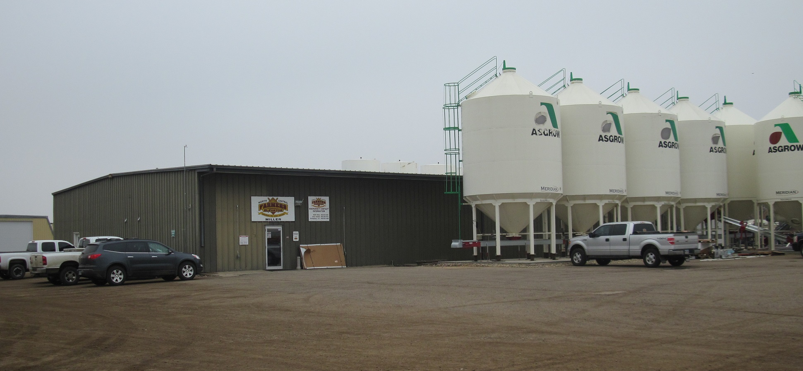
204-0721 (24 hour emergency #)

List of Reportable Quantity Chemicals
Chemical | Fire Hazard | Acute Health Hazard | Chronic Health Hazard
Ammonium Sulfate 21-0-0-245 | X
Extreme |  | X
Harness Extra | X | X | X
MAP 11-52-0 | X
MESIO 12-40-0-16 | X
Potash | X
Roundup Powermax | X | X
Roundup RT3 | X | X
Urea 46-0-0 | X

North Central Farmers Elevator – Miller Bulk Plant
120 SE 3rd Ave
Miller, SD 57362
853-2351

Andy Clemen, Safety Director 216-2587
216-2587 (24 hour emergency #)
Jerry VanZee, Manager 853-2351
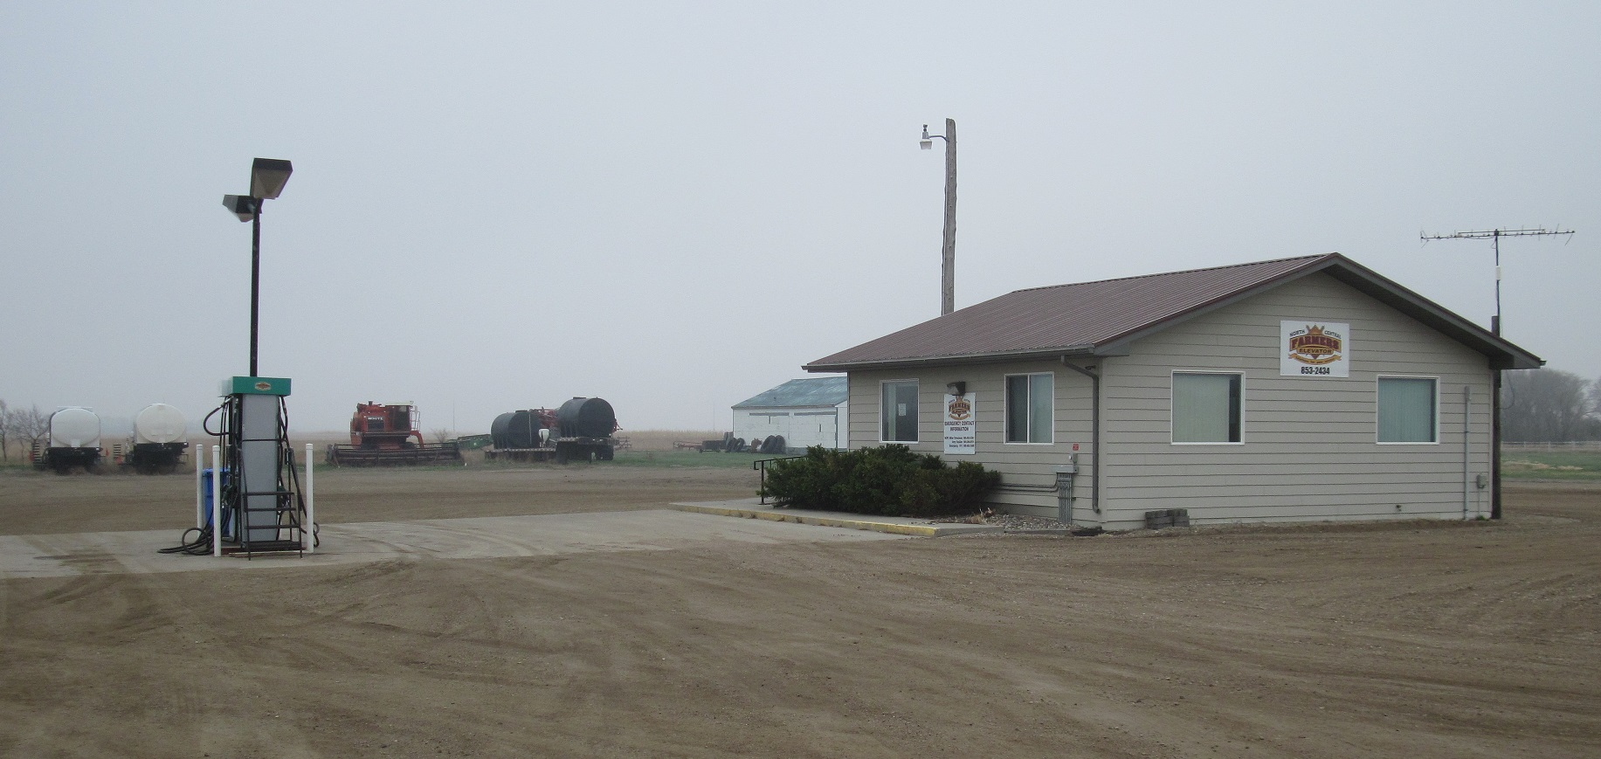
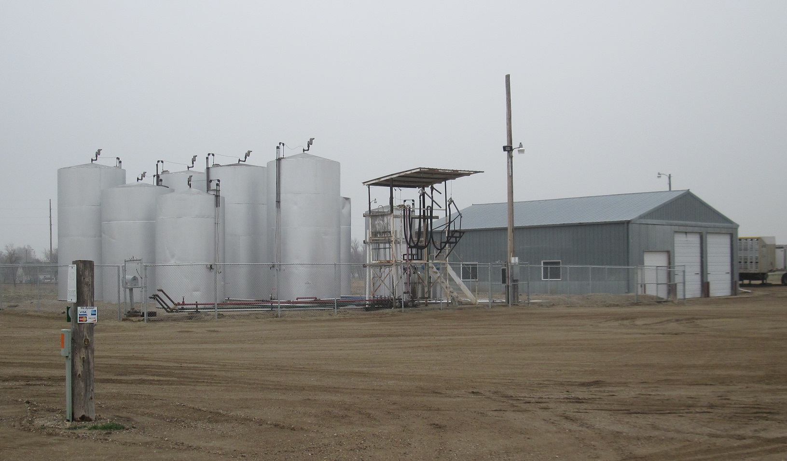
204-0721 (24 hour emergency #)
List of Reportable Quantity Chemicals
Chemical | Fire Hazard | Acute Health Hazard | Chronic Health Hazard
Diesel fuel | X | X | X
Gasoline | X | X | X

North Central Farmers Elevator – Rockham Bulk Plant
18095 365th Ave
Rockham, SD 57470

Andy Clemen, Safety Director 216-2587
216-2587 (24 hour emergency #)

Keith Komraus, Manager 450-8562
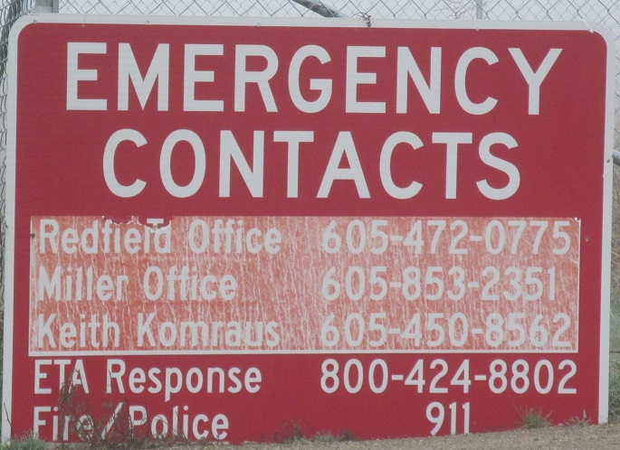
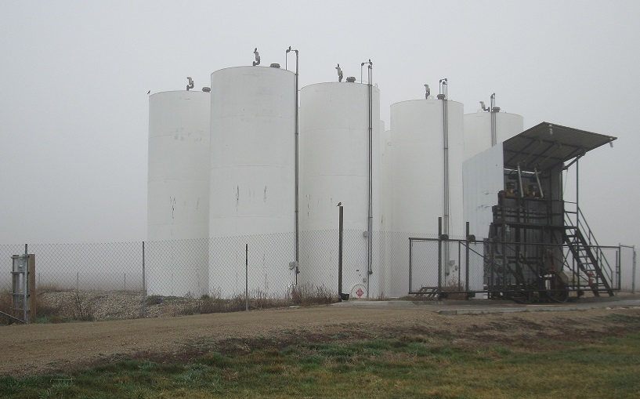
450-8562 (24 hour emergency #)

List of Reportable Quantity Chemicals
Chemical | Fire Hazard | Acute Health Hazard | Chronic Health Hazard
Gasoline | X | X | X
Diesel | X | X | X

Pump N Pak
709 N Broadway Ave
Miller, SD 57362
853-3758

Lorili Simons, Owner 853-3758
870-8625 (24 hour emergency #)
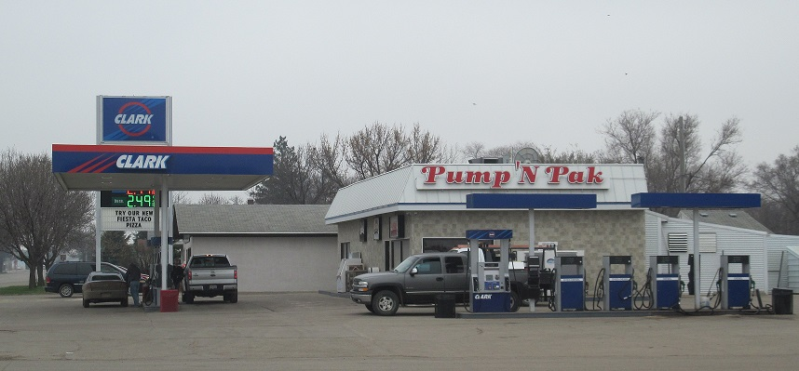

List of Reportable Quantity Chemicals
Chemical | Fire Hazard | Acute Health Hazard | Chronic Health Hazard
List of Reportable Quantity Chemicals Not Available

South Dakota Soybean Processors
36579 US Hwy 14
St Lawrence, SD 57373
605-853-0024 (office)

John Prohaska, Op. Group Manager 627-6121
690-1547 (24 hour emergency #)

Jay Wells, Operations Manager 853-0024
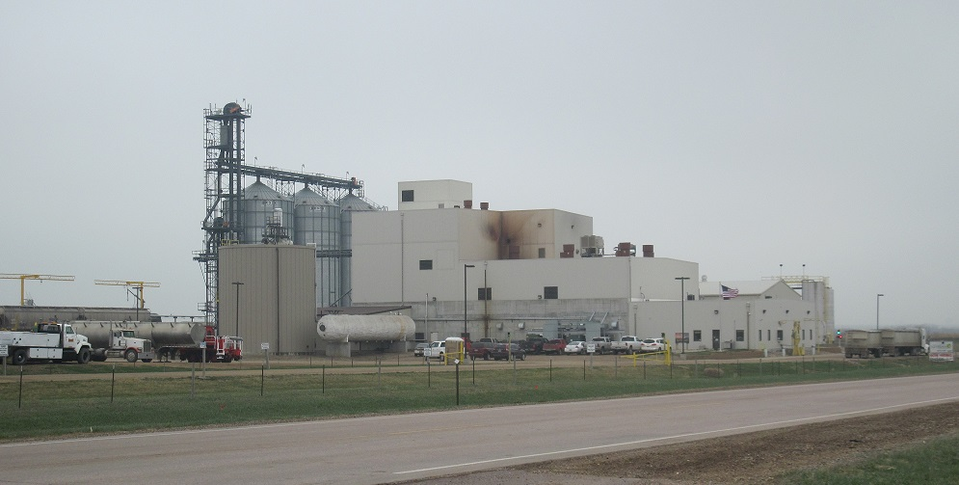
651-0331 (24 hour emergency #)

List of Reportable Quantity Chemicals
Chemical | Fire Hazard | Acute Health Hazard | Chronic Health Hazard
Crude Soybean oil | X

South Dakota Wheat Growers – Miller Agronomy
35884 US Highway 14
Miller, SD 57362
853-3006

Don Herman, Agronomy Manager 853-3006
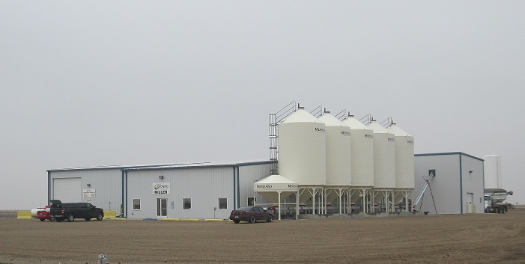
870-0905 (24 hour emergency #)
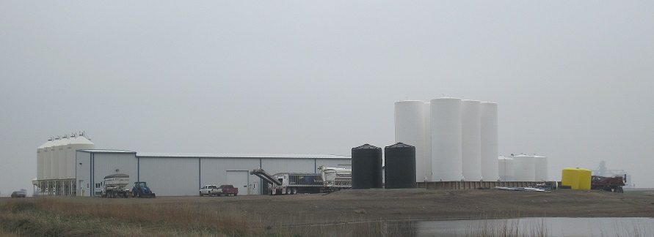

South Dakota Wheat Growers – Miller Agronomy
35884 US Highway 14
Miller, SD 57362
853-3006

List of Reportable Quantity Chemicals
Chemical | Fire Hazard | Acute Health Hazard | Chronic Health Hazard
10-34-00 Liquid Fertilizer |  | X
28-00-00 Liquid Fertilizer |  | X
Class Act - Water Conditioner |  | X
Diesel Fuel | X | X | X
Extreme Herbicide |  | X
Halex GT |  | X
Propane | X | X
Roundup Powermax |  | X
TripleFlex Herbicide | X | X | X
Warrent Herbicide |  | X | X
Widematch Herbicide |  | X | X
Zinc |  | X

South Dakota Wheat Growers – St Lawrence
1 S Commercial Ave
St Lawrence, SD 57373
853-2728 (office)

Randy Bertsch, Location Manager 853-2728
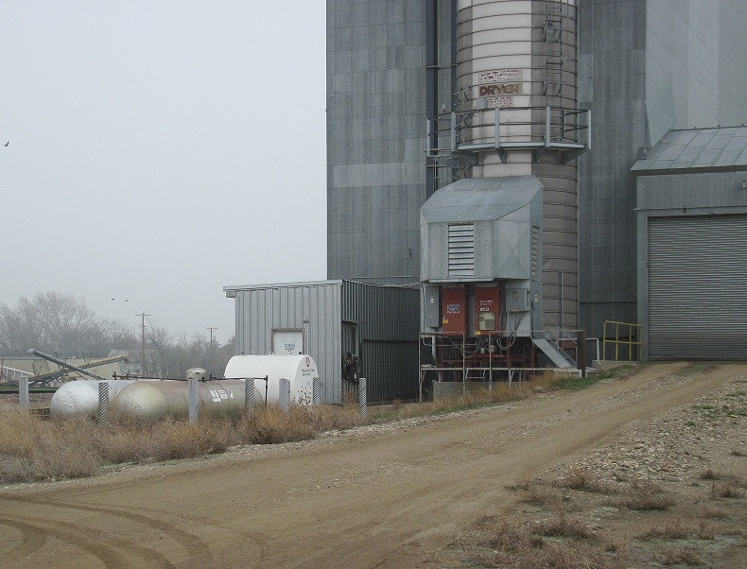
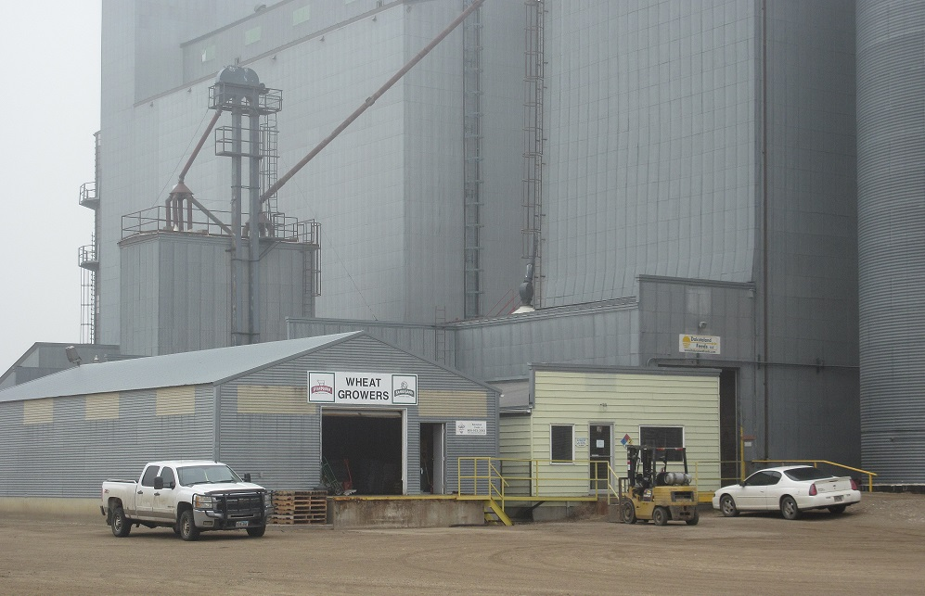
870-1305 (24 hour emergency #)
List of Reportable Quantity Chemicals
Chemical | Fire Hazard | Acute Health Hazard | Chronic Health Hazard
Grain Dust | X | X | X
Propane | X | X

Titan Wind Farm
606 W 14th St
Miller, SD 57362
204-0879

Stefan Jones, Facility Tech 204-0879
204-0879 (24 hour emergency #)
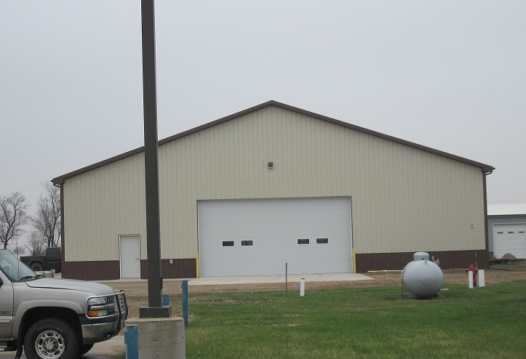

List of Reportable Quantity Chemicals
Chemical | Fire Hazard | Acute Health Hazard | Chronic Health Hazard
Lead Acid Battery | X | X | X
Lubricating Oil | X | X
Transformer Oil | X | X

Wilbur-Eills Company LLC – Miller Air
609 W 14th St
Miller, SD 57362
853-2382

Daniel Jensen, Ops Manager 853-2382
461-9189 (24 hour emergency #)
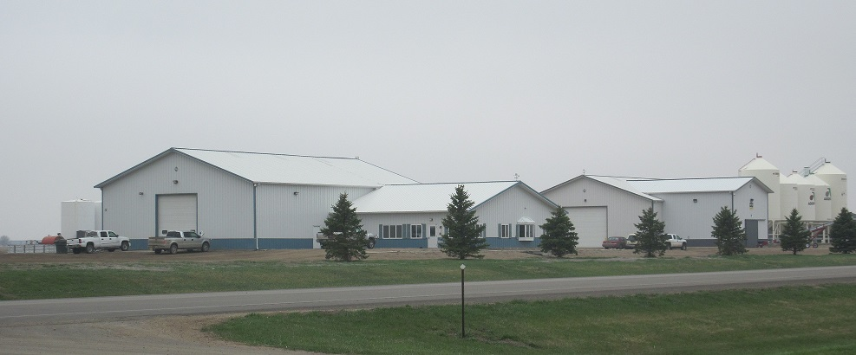

Wilbur-Eills Company LLC – Miller Air
609 W 14th St
Miller, SD 57362
853-2382

List of Reportable Quantity Chemicals
Chemical | Fire Hazard | Acute Health Hazard | Chronic Health Hazard
Acetochlor Liquid | X | X | X
Ammonium Nitrate Liquid |  | X
Ammonium Polyphosphate Liquid |  | X
Ammonium Sulfate |  | X
Atrazine Liquid |  | X | X
EDTA Liquid |  | X
Glyphosate, IPA Salt Liquid |  | X
Glyphosate, Potassium Salt Liquid |  | X | X
Magnesium Sulfate |  | X
Monoammonium Phosphate |  | X
Monoammonium Phosphate Liquid |  | X
Paraquat Dichloride | X | X | X
Potassium Chloride |  | X
Potassium Hydroxide Liquid |  | X | X
Potassium Magnesium Sulfate |  | X
Sulfur |  | X
Urea |  | X
Urea Liquid |  | X
Zinc Sulfate |  | X | X

HAZARDOUS MATERIALS TRANSPORTATION ROUTES & MAPS

Reference Same Section In Your LEPC Handbook

Click here to enter text.

CHEMICAL SUMMARY AND INFORMATION

Reference Same Section In Your LEPC Handbook

Click here to enter text.
LIST OF REPORTABLE QUANTITY CHEMICALS

Chemical | Fire Hazard | Acute  Health Hazard | Chronic  Health Hazard
10-34-00 Liquid Fertilizer |  | X
28-00-00 Liquid Fertilizer |  | X
Acetochlor Liquid | X | X | X
Ammonium Nitrate Liquid |  | X
Ammonium Polyphosphate Liquid |  | X
Ammonium Sulfate |  | X
Ammonium Sulfate 21-0-0-245 | X
Atrazine Liquid |  | X | X
Class Act - Water Conditioner |  | X
Crude Soybean oil | X
Diesel Fuel | X | X | X
E-85 | X | X | X
EDTA Liquid |  | X
Extreme Herbicide |  | X
Gasoline | X | X | X
Glyphosate, IPA Salt Liquid |  | X
Glyphosate, Potassium Salt Liquid |  | X | X
Grain Dust | X | X | X
Halex GT |  | X
Harness Extra | X | X | X
Heating Fuel | X | X
Lead Acid Battery | X | X | X
Lubricating Oil | X | X
Magnesium Sulfate |  | X
MAP 11-52-0 | X
MC Road Oil | X |  | X
MESIO 12-40-0-16 | X
Monoammonium Phosphate |  | X
Monoammonium Phosphate Liquid |  | X
Oxygen | X
Paraquat Dichloride | X | X | X
Potash | X
Chemical | Fire Hazard | Acute  Health Hazard | Chronic  Health Hazard
Potassium Chloride |  | X
Potassium Hydroxide Liquid |  | X | X
Potassium Magnesium Sulfate |  | X
Propane | X | X
RC Road Oil | X |  | X
Roundup Powermax | X | X
Roundup RT3 | X | X
SNL Gasoline W/Ethanol | X | X | X
Sulfur |  | X
Sulfuric Acid |  | X
Transformer Oil | X | X
TripleFlex Herbicide | X | X | X
Urea |  | X
Urea 46-0-0 | X
Urea Liquid |  | X
Warrent Herbicide |  | X | X
Widematch Herbicide |  | X | X
Zinc |  | X
Zinc Sulfate |  | X | X

GENERAL GUIDELINES

FOR ALL

EMERGENCY RESPONDERS

Reference Same Section In Your LEPC Handbook

Click here to enter text.
- Spill Notification Procedures
  - Call Fire Department
  - Call Ambulance (If needed)
  - Call Public Safety Center (Sheriff’s Office)
    - If no answer at Fire Department or the Public Safety Center call the State of South Dakota Emergency Release Hotline and report the spill.
  - Evacuate building!
- Optional
  - If possible, turn off power to property to prevent possible fires / explosions prior to evacuating property.
  - If possible, prevent chemicals from entering sewers and floor drains.
  - If possible, prevent on-lookers / bystanders from entering the property / affected area.
  - Stay up-wind from the affected area.

- On-site Evacuation Plans (Employee Instructions)

- Emergency Resources
  - List all dedicated special use equipment / supplies to be used in the event of a chemical release / spill. If none state so.
  - Chemical Collection Sump
  - Chemical Containment Curbing System
  - Emergency Electrical Disconnect
  - Fire Extinguisher
  - First Aid Kit

- Facility Location Map

EVALUATION SHEET FOR
TITLE III LEPC PLANS

COUNTY: HAND

ADDRESS REQUIRED ELEMENTS AND GENERAL COMMENTS:

Click here to enter text.

TO: State Emergency Response Commission
Department of Environment and Natural Resources
523 East Capitol Street - Foss Building
Pierre, SD 57501

FROM: Click here to enter text.

DATE: Click here to enter text.

SUBJECT: SARA Title III Reporting Requirements

I have determined that during certain periods of the year I have present on my farm/property reportable quantities of substances as listed in Part 302 of the Act.

I request that you notify the Local Emergency Planning Committee (LEPC) in Click here to enter text. County of the presence of these

I have Click here to enter text.have not Click here to enter text.attached a list of these substances, the time of year present and the quantities present.

I have designated the following individual as the representative to work with the LEPC.

NAME Click here to enter text.

ADDRESS Click here to enter text.

PHONE #: Click here to enter text.

FARMERS AND SARA TITLE III

Q. Are farmers covered by Title III? If so, why? What exactly do farmers have to do?

A. There are four major reporting requirements under Title III: emergency planning notification (SS302); emergency release notification (SS304); community right-to-know (SS311 material safety data sheets and SS312 emergency and hazardous chemical inventory forms); and toxic chemical release forms (SS313 “emissions inventory”). Each reporting provision has different requirements for chemicals and facilities covered. Due to this complexity in the statute itself, each section must be read carefully to understand the chemicals covered and the facilities to which the section applies. Farmers may be subject to several of the reporting requirement of Title III.

Emergency Planning Notification (SS302)

Farm owners and operators are most likely to be subject to the emergency planning requirements of SS302. Farms were not exempted from this provision, since the law was designed to generally identify all facilities that have any of the listed 406 extremely hazardous substances present in excess of its threshold planning quantity (TPQ). The TPQ is based on the amount of any one of these substances which could, upon release, present human health hazards which warrant emergency planning. The TPQ emergency planning trigger is based on these public health concerns rather that the type of facility where the chemicals might be located. The type of facility and degree of hazard presented at any particular site, however, are relevant factors for consideration by the local emergency planning committees.

While many farms with such chemicals in such quantities may not present a significant hazard to their communities due to their rural location or short holding times, other farms may well present a potentially significant hazard if the chemicals are located in a suburban, populated area or near a school, hospital, or nursing home. Even in a rural area, large volume storage could also be a concern. Although these substances may only be stored or used periodically, there is always the possibility of accidents which could present a hazard to the community. Finally, in the event of a fire or other emergency on the farm, local responders should know what chemicals they might encounter in order to take appropriate precautionary measures. The assessment of the hazard posed by an individual farm or ranch must be made on a site specific basis. Communities must know which facilities may present a potential for chemical releases so they can determine the nature of the risk to the public and to emergency responders in the event of a release. Title III established State and local planning organizations and notification requirements to meet these needs. Local emergency planning committees can best address these concerns by working with farm representatives.

To meet the emergency planning requirements of Title III, farm owners and operators must:

1. Make a determination if they have any of the listed 406 substances in excess of the threshold planning quantity present on their farms at any one time at concentrations greater than one percent by weight. This requirement applies even if the chemicals to this requirement for farms or for substances used in routine agricultural operations.

2. If one or more of the 406 substances is present in excess of its TPQ, simply notify (preferably in writing) their State Emergency Response Commission (SERC), which in turn will notify the appropriate local emergency planning committee. The notification is not required to include the names and quantities of the substances (determined in 1 above), but we encourage the submission of such information, because it will be useful to the SERC and the local committees in organizing and prioritizing emergency planning activities. This notification was required by May 17, 1987 or
60 days after the threshold planning quantity is exceeded for at least one extremely hazardous substance, whichever is later. If such notification has not been made, farm owners and operators should do so immediately.

This is a one-time notification that the farm has any of these chemicals present in excess of its threshold planning quantity. Once such notification is made, the owner is not required to make additional notifications for other extremely hazardous substances that may become present on the farm during the year, but may be required to inform the local emergency planning committee of such changes.

Also, the Environmental Protection Agency (EPA) may revise the list of extremely hazardous substances. A facility which has present any substance added to the list but which has not previously notified must then make notification to the SERC and the local emergency planning committee within 60 days. EPA does not have immediate plans to add substances to this list.

3. If the farm was required to notify under paragraph 2, designate a representative to work with the local emergency planning committee to address the need, if any, for emergency planning around their farm. Local emergency planning committees are to be established by the SERC by August
17, 1987. There is no requirement for farm owners or operators to develop a farm emergency plan. A comprehensive emergency response plan is to be developed by the local emergency planning committee for the local emergency planning district it covers. This plan should address, to the extent possible, all potential chemical release hazards in the district including, where appropriate, chemicals on farms.

Emergency Release Notification 304

Farmers may also be covered by the emergency notification requirements (304) if they release any of the
406 listed extremely hazardous substances or Superfund hazardous substances in excess of its reportable quantity (RQ). Reportable quantities are the amounts of these substances, which, if released, must be reported. (RQs for Superfund hazardous substances are specified in EPA regulations found in 40 Code of Federal Regulations (CFR) Table 302.4, available in public libraries and EPA Regional Offices or by contacting EPA’s Chemical Emergency Preparedness Hotline at 1-800-424-8802.) Section 304 requires reporting of such releases to the State Emergency Response Commission and local emergency planning committees in addition to reporting releases of Superfund hazardous substances to the National Response Center (1-800-424-8802), which has been required since 1980. Section 304 also requires a written follow-up emergency notice to the State Commission and local committee.

However, the release of a pesticide registered under the Federal Insecticide, Fungicide, and Rodenticide Act (FIFRA) when used generally in accordance with its intended purpose (e.g., during routine agricultural applications according to approved product label instructions) is exempted from this reporting. Also, normal application of fertilizer would not need to be reported. However, an accidental release of such substances (or other release not generally in accord with its intended purpose) in excess of the RQ must be reported.

Title III emergency release notification (304) has two limitations which are not present in Superfund release reporting. First, Title III (304) release reporting is only applicable at facilities which produce, use, or store a “hazardous chemical”. Because the definition of “hazardous chemical” in Title III specifically excludes substances used in routine agricultural operations and household or consumer products, some farms or ranches will not be subject to 304. Secondly, releases reportable under 304 include only those releases which have potential for off-site exposure (and also equal or exceed the applicable reportable quantity for that substance). Thus, spills of pesticides which would require release reporting to the National Response Center under Superfund, would not be subject to local and State reporting under 304 unless there were a potential for off-site exposure.

Community Right-to-Know (311 - 312)

Community right-to-know reporting (311-312), while currently limited to Standard Industrial Classification (SIC) Codes 20-39, (mainly manufacturers and importers) may cover some farms or ranches if they have manufacturing operations on-site (e.g., food processing, canning, winemaking).

Even if Sections 311 and 312 become applicable beyond the manufacturing sector as a result of any expansion of the Occupational Safety and Health Administration (OSHA) hazard communication standard (on which 311 - 312 reporting is based), chemicals used in routine agricultural operations and household or consumer products will not be subject to these reporting requirements. Chemicals used for such purposes are excluded from the Title III definition of “hazardous chemical” to which the reporting requirement applies.

Toxic Chemical Release Forms (313)

Toxic Chemical release reporting (313) is limited to facilities in SIC Codes 20 - 39 with 10 or more full time employees, but may, as indicated above, apply to farms or ranches with on-site manufacturing operations.

Title III also includes various provisions for civil, administrative and criminal penalties and citizen suits for failure to comply with the requirements of the law.

For assistance in meeting these requirements, farmers may call on their State and county offices of the USDA Agricultural Stabilization and Conservation Service, which have the rulemaking list of 406 chemicals, their TPQs and RQs and a list of SERCs. They may also call EPA’s Chemical Emergency Preparedness Program Hotline at 1-800-535-0202.

GLOSSARY

Acute Toxicity - The ability of a substance to cause poisonous effects resulting in severe biological harm or death soon after single exposure or dose. Also, any severe poisonous effect resulting from a single short term exposure to a toxic substance.

CAER - Community Awareness and Emergency Response Program which provides guidelines for chemical plant managers to assist them in taking steps to cooperate with local communities to develop integrated community/industry hazardous materials response plans.

CAS # - Chemical Abstracts Service Registry Number, a number assigned to toxic/hazardous substances.

CEPP - Chemical Emergency Preparedness Program, a voluntary initiative developed by EPA for addressing accidental releases of toxic substances.

CERCLA - Comprehensive Emergency Response, Compensation, and Liability Act regarding the cleanup of uncontrolled hazardous waste sites and response to releases of hazardous substances.

CERCLA Hazardous Substances - Substances defined under:
1. Federal Water Pollution Act (Sections 102 &
307)
2. Solid Waste Disposal Act (Section 300)
3. Clean Air Act (Section 112)
4. Toxic Substance Control Act (Section 7)

Chemical Name - The scientific designation of a chemical in accordance with The nomenclature system developed by the International Union of Pure and Applied Chemistry (IUPAC) or the Chemical Abstracts Service (CAS) rules of nomenclature, or a name which will clearly identify the chemical for the purpose of conducting a hazard evaluation.

CHEMTREC - Chemical Transportation Emergency Center operated by the Chemical Manufacturers Association. This center provides information and/or assistance to emergency responders of toxic substance releases. CHEMTREC may contact the shipper/ producer of the material for more detailed information and can be reached 24 hours a day by calling 1-800-424-9300.

Chronic Toxicity - The capacity of a substance to cause long-term poisonous human health effects. (See: acute toxicity)

Commission - The State Emergency Response Commission (or, for the purpose of emergency planning, the Governor if there is no commission) for the state in which the facility is located.

Common Name - Any designation or identification such as a code name, code number, trade name, brand name or generic name used to identify a chemical other than by its chemical name.

Confinement - Control methods used to limit the physical area or size of a released material. Examples: dams, dikes, and absorption processes.

Containment - Control methods used to keep the material in its container. Examples: plugging and patching.

Control - Chemical or physical methods used to prevent or reduce the hazards associated with a material. Example: neutralizing an acid spill.

Corrosive - A chemical agent that reacts with the surface of a material causing it to deteriorate or wear away.

Decontamination - The process of physically removing contaminants from individuals and equipment or changing their chemical nature to innocuous substances.

Degree of Hazard - A relative measure of how much harm a substance can do.

DENR - Department of Environment and Natural Resources.

Emergency (Chemical) - A situation created by an accidental release or spill of hazardous chemicals which poses a threat to the safety of workers, residents, the environment, or property.

Environmental Assessment - The measurement or prediction of the concentration, transport, dispersion, and final fate of a released hazardous substance in the environment.

Environmental Emergencies - Incidents involving the release (or potential release) of hazardous materials into the environment which require immediate action.

Environmental Hazard - A condition capable of posing an unreasonable risk to air, water, or soil quality, and to plants and wildlife.

EPA - The US Environmental Protection Agency.

ERT - EPA’s Emergency Response Team of highly specialized experts who are available on a 24 hour a day basis.

Extremely Hazardous Substances (EHS) - Substances listed in Appendices A and B of 40
CFR Part 355. Any of 366 chemicals identified by EPA on the basis of toxicity, and listed under SARA Title III. The list is subject to revision.

Facility - All buildings, equipment, structures, and other stationary items which are located on a single site or on adjacent sites which are owned or operated by the same person/persons.

Hazard - A circumstance or condition that can do harm. Hazards are categorized into four groups: biological, chemical, radiological, and physical.

Hazard Evaluation - The impact or risk a hazardous substance poses to public health and the environment.

Hazardous - Capable or posing an unreasonable risk to health and safety. Capable of doing harm.

Hazardous Chemical - Any substance or mixture which requires a business to keep, prepare, or provide a Material Safety Data Sheet as required by the Occupational Safety and Health Administration (OSHA). The criteria that determines this are toxicity, reactivity, flammability, and sudden release of pressure.

Hazardous Chemicals - Those chemicals which are a physical hazard or health hazard.

Hazardous Material - A substance or material which has been determined by the Secretary of Transportation to be capable of posing an unreasonable risk to health, safety, and property when transported in commerce, and which has been so designated. (Department of Transportation)

Hazardous Substance
1. Any material that poses a threat to human health and/or the environment. Typical hazardous substances are toxic, corrosive, ignitable explosive, or chemically reactive.
2. Any substance designated by EPA to be reported if a designated quantity of the substance is spilled in the waters of the United States or if otherwise emitted to the environment.

Hazards Analysis - The procedures involved in
1. identifying potential sources of release of hazardous materials from fixed facilities or transportation accidents;
2. determining the vulnerability of a geographical area to a release of hazardous material; and
3. comparing hazards to determine which present greater or lesser risks to a community.

Hazards Identification - Providing information on which facilities have extremely hazardous substances, what those chemicals are, and how much there is at each facility. The process also provides information on how the chemicals are stored and whether they are used at high temperatures.

Health Hazard - A chemical for which there is statistically significant evidence that acute or chronic health effects may occur in exposed employees. The term “health hazard” includes chemicals which are carcinogens, toxic or highly toxic agents, reproductive toxins, irritants, corrosives, sensitizers, hepatotoxins, nephrooxins, neurotoxins agents which act on the hematopoietic system, and agents which damage the lungs, skin, eyes, or mucous membranes.

Local Emergency Planning Committee (LEPC)
- A Committee appointed by the state emergency response commission, as required by SARA Title III, to formulate a comprehensive emergency plan for its jurisdiction.

Material Safety Data Sheet (MSDS) – A compilation of information required under the OSHA Communication Standard on the identity of hazardous chemicals, health, and physical hazards, exposure limits, and precautions. Section 311 of SARA requires facilities to submit MSDS under certain circumstances.

Mitigation - Actions taken to prevent or reduce the severity of threats to human health and the environment.

Mixture - Any combination of two or more chemicals if the combination is not, in whole or in part, the result of a chemical reaction.

NCP - National Oil and Hazardous Substances Pollution Contingency Plan which put into effect the response powers and responsibilities created by CERCLA and the authorities established by section 311 of the Clean Water Act.

NRC - National Response Center which is a communications center for activities related to response actions in dealing with releases of toxic or hazardous substances. The NRC can be reached on a 24 hour a day basis by calling 1-800-424-8802.

NRT - National Response Team, the principal organization for implementing the NCP and consists of representatives of 14 government agencies. (DOD, DOI, DOT/RSPA, DOT/USCG, EPA, DOC, FEMA, DOS, USDA, DOJ, HHS, DOL, NRC, and DOE).

OSHA Hazard Communication Standard - Developed by OSHA to ensure that the hazards of all chemicals produced or imported by the chemical manufacturers or importers are evaluated, and that information concerning their hazards is transmitted to affected employers and employees within the manufacturing sector.

Physical Hazard - A chemical for which there is scientifically valid evidence that it is a combustible liquid, a compressed gas, explosive, flammable, an organic peroxide, an oxidizer, pyrophoric, unstable (reactive) or water-reactive.

Plume
1. A visible or measurable discharge of a contaminant from a given point of origin. Can be visible or thermal in water, or visible in the air as, for example, a plume of smoke.
2. The area of measurable and potentially harmful radiation leaking from a damaged reactor.
3. The distance from a toxic release considered dangerous for those exposed to the leaking fumes.

RCRA - Resource Conservation and Recovery Act which establishes a framework for the proper management and disposal of all wastes.

Release - Any spilling, leaking, pumping, pouring, emptying, discharging, injecting, escaping, leaching, dumping, or disposing into the environment.

Response Actions - Actions taken to recognize, evaluate, and control an incident.

Risk Assessment - The quantitative and qualitative evaluation performed in an effort to define the risk posed to human health and/or the environment by the presence or potential presence and/or use of specific pollutants.

Risk Communication - The exchange of information about health or environmental risks between assessors, risk managers, the general public, news media, interest groups, etc.

RQ - Reportable Quantity, which is the minimum quantity of a chemical a facility may have before having to notify local and state officials.

RRT - Regional Response Teams, composed of representatives of Federal agencies and a representative from each State in the Federal region. During a response to a major hazardous materials incident involving transportation or a fixed facility, the RRT may provide advice or recommendations in specific issues requiring resolution.

SARA - Superfund Amendments and Reauthorization Act of 1986.

SARA Title III -
1. The Emergency Planning and Community
Right-to-Know Act of 1986.
2. Title III of the Superfund Amendments and and Reauthorization Act

SERC - State Emergency Response Commission established by each state governor according to the requirements of SARA Title III. The SERCs designate emergency planning districts, appoint local emergency planning committees, and supervise and coordinate their activities.

SIC Code - Standard Industrial Classification Code - Four-digit numerical codes established by the Office of Management and Budget to identify the activities carried out by businesses.

Site Safety Plan - Written, site-specific safety criteria that establishes requirements for protecting the health and safety of responders during all activities conducted at an incident.

Specific Chemical Identity - The chemical name, Chemical Abstracts Service Registry umber(CAS#), or any other information that reveals the precise chemical designation of the substance.

Tier II Report - Chemical inventory report used by facilities to list chemicals at their facility with the Local Emergency Planning Committee, State Emergency Response Commission, and their jurisdictional fire department.

Title III - The Emergency Planning and Community Right-to-Know Act of 1986. This act specifies requirements for organizing the planning process at state and local levels for specified hazardous substances. This act also specifies minimum plan content, requirements for facility owners/operators to notify officials of extremely hazardous substances present at the facilities, and mechanisms for making information available to citizens. In addition, the law requires disclosure of information about the presence of hazardous chemicals in the community.

Toxic Chemical Release Form (Form R) - Information form required to be submitted by facilities that manufacture, process, or use (in quantities above a specific amount) chemicals listed under SARA Title III.

Reauthorization Act. Toxics Release Inventory (TRI) - Information compiled from Form R reports submitted by facilities covered by Section 313 of SARA Title III.

TPQ - Threshold Planning Quantity - A quantity designated for each chemical on the EHS (extremely hazardous substances) list that triggers notification by facilities to the state emergency response commission and the LEPC that such facilities are subject to emergency planning under SARA Title III.

Trade Secret - Any confidential formula, pattern, process, device, information or compilation of information that is used in an employer’s business, and that gives the employer an opportunity to obtain an advantage over competitors who do not know or use it.

ACRONYMS

BLEVE - Boiling Liquid Expanding Vapor Explosion.

CAER - Community Awareness and Emergency Response

CAMEO – Computer Aided Management of Emergency Operations

CASRN - Chemical Abstracts Service Registry Number.

CEPP Chemical Emergency Preparedness Program.

CERCLA – Comprehensive Emergency Response, Compensation, and Liability Act.

CFR - Code of Federal Regulations.

CHEMTREC – Chemical Transportation Emergency Center 1-800-424-9300

CPG - Civil Preparedness Guide.

CPG 1-8 - Guide for Development of State and Local EOPs.

CPG 1-8a - Guide for Review of State and Local EOPs.

CPG 1-35 - Hazard ID, Capability Assessment, and Multi-year Development Plan

CRC - Contamination Reduction Corridor.

DENR - South Dakota Department of
Environment and Natural Resources.

DERA - Designated Emergency Response
Authority.

DOT - Department of Transportation.

EBS – Emergency Broadcast System

EHS – Extremely Hazardous Substances

EMI - Emergency Management Institute, Part of NETC.

EOC - Emergency Operations Center

EOP - Emergency Operations Plan.

EPA - Environmental Protection Agency.

EPCRA - Emergency Planning and Community Right-to-Know Act.

ERT - Emergency Response Team.
Emergency Center 1-800-424-9300.

FEMA Federal Emergency Management Agency

FIFRA - Federal Insecticide, Fungicide, and Rodenticide Act.

HAZMAT - Hazardous Materials.

HAZWOPER - Hazardous Waste Operations and Emergency Response Act.

HC -Hazardous Chemicals.
HMCP Hazardous Materials Contingency Planning

HMFAP – Hazardous Materials Financial Assistance Project.

HMIX – Hazardous Materials Information Exchange.

HMTA - Hazardous Materials Transportation Act.

HMTUSA - Hazardous Materials Transportation Uniform Safety Act; now the HMTA.

IC - Incident Commander.

LEL - Lower Explosive Limit.

LEPC - Local Emergency Planning Committee.

MSDS - Material Safety Data Sheet.

NETC - National Emergency Training Center.

NFA - National Fire Academy, Part of NETC.

NRC - National Response Center.

NRT - National Response Team.

NRT-1 - Emergency Planning Guide issued by NRT.

OEM - South Dakota Office of Emergency Management.

OSHA - Occupational Safety and Health Administration.

PIO - Public Information Officer.

PPE - Personal Protective Equipment.

RCRA - Resource Conservation and Recovery Act.

RQ - Reportable Quantity.

SARA -- Superfund Amendments and Reauthorization Act.

SCBA - Self-Contained Breathing Apparatus.

SERC - State Emergency Response Commission.

SOP - Standard Operating Procedures.

TC - Toxic Chemicals.

Title III - Third part of SARA, also known as the
EPCRA.

TLV - Threshold Limit Valve.

TPQ - Threshold Planning Quantity.

TRANSCAER – Transportation Community Awareness and Emergency Response

TRI - Toxic Release Inventory.

USDA - United States Department of Agriculture.

UST - Underground Storage Tank.

APPENDIX A

HAZARDOUS MATERIAL INCIDENT REPORTING INFORMATION

HAZARDOUS MATERIAL INCIDENT REPORTING INFORMATION*

DATE:Click here to enter text. TIME: Click here to enter text.AGENCY: Click here to enter text.

NAME OF CALLER: Click here to enter text. TELEPHONE NUMBER: Click here to enter text.

TYPE OF INCIDENT / ACCIDENT: Click here to enter text. LOCATIONClick here to enter text.

TIME OF OCCURRENCE: Click here to enter text. ANY INJURY / DEATH? YES  NO 

PLACARD: YES NO  IF YES, IDENTIFICATION NUMBER: Click here to enter text.

MATERIAL / PRODUCT INVOLVED (CORRECT SPELLING): Click here to enter text.

TYPE OF CONTAINER: Click here to enter text.AMOUNT: Click here to enter text.

SPILL SIZE: Click here to enter text.

ENDANGERED AREA: Click here to enter text. POPULATION AREA: Click here to enter text.
SPILL MOVEMENT YES NO 

WATER BODIES / STREAMS INVOLVED? YES NO  IF YES, NAME: Click here to enter text.

IMMEDIATE THREAT  HUMAN  WILDLIFE  WATER SUPPLY  FISHLIFE 
OTHER: Click here to enter text.

CURRENT WEATHER CONDITIONS (AT THE SCENE)WIND SPEED & DIRECTION: Click here to enter text.

TEMPERATURE: Click here to enter text. CLIMATE: Click here to enter text.

CURRENT OR POTENTIAL HEALTH PROBLEM: Click here to enter text.

SHIPPER / MANUFACTURER NAME: Click here to enter text.ADDRESS: Click here to enter text.
PHONE NUMBER: Click here to enter text.

TRUCK DRIVER IDENTIFICATION
NAME: Click here to enter text. ADDRESS: Click here to enter text. PHONE NUMBER: Click here to enter text.

PERSONNEL / AGENCY (IES) AT SCENE: Click here to enter text.

OTHER FACTS / REMARKS: Click here to enter text.
* THE OFFICE OF EMERGENCY MANAGEMENT (605-773-3231, 24 HOUR EMERGENCY PHONE NUMBER) MUST BE
NOTIFIED AS SOON AS POSSIBLE AFTER RECEIPT OF INCIDENT REPORT.

WRITTEN HAZARDOUS MATERIAL INCIDENT REPORT FOLLOW-UP REPORT

DATE: Click here to enter text. TIME: Click here to enter text.
CONTACT PERSON: Click here to enter text. ADDRESS: Click here to enter text.
PHONE: (WORK)Click here to enter text. (HOME)Click here to enter text.
LOCATION OF INCIDENT: Click here to enter text.

IDENTITY OF SUBSTANCE / MATERIAL: Click here to enter text.
TRADE NAME: Click here to enter text.
CHEMICAL NAME: Click here to enter text. CAS # Click here to enter text.

Click here to enter text. Click here to enter text.

Click here to enter text. Click here to enter text.

Click here to enter text. Click here to enter text.

IS THIS SUBSTANCE ON THE SARA 302 LIST? YES:  Click here to enter text. NO: Click here to enter text.
DO NOT KNOW: Click here to enter text. 

WHAT QUANTITY OF THE SUBSTANCE WAS RELEASED: Click here to enter text.

WHAT TIME DID THE RELEASE BEGIN: Click here to enter text.
WHAT WAS THE DURATION OF THE RELEASE: Click here to enter text.
WHAT WAS AFFECTED BY THE RELEASE (AIR/WATER/SOIL): Click here to enter text.
IDENTIFY KNOWN ACUTE OR CHRONIC HEALTH RISKS: Click here to enter text.

WHAT PERTINENT MEDICAL ADVICE WAS ISSUED: Click here to enter text.

PROVIDE ADDITIONAL INFORMATION DESCRIBING THE INCIDENT AND ACTIONS TAKEN, ON THE
BACK SIDE OF THIS FORM. WHEN COMPLETED MAIL THIS REPORT TO:

SOUTH DAKOTA EMERGENCY RESPONSE COMMISSION DEPARTMENT OF WATER & NATURAL RESOURCES OFFICE OF AIR QUALITY & SOLID WASTE
523 EAST CAPITOL STREET, ROOM 217
PIERRE, SD 57501 (605) 773-3153

